PROJECT REPORT (MS-100)

ON

AN ANALYTICAL STUDY OF IMPLEMENTATION OF SIX SIGMA AND LEAN INDUSTRY:-

(A CASE STUDY OF ESSAR GLOBAL FUND LIMITED)

Submitted by:

GEETANJALI SHARMA
Enrollment No. 183959624
Specialization: Operations Management

Under the guidance of:

DR. MOHENDER KUMAR GUPTA
(Head & Associate Professor- Dept. of Commerce & Management –Pt. J.L.N. Government College, Faridabad)

Submitted to:

SCHOOL OF MANAGEMENT STUDIES
INDIRA GANDHI NATIONAL OPEN UNIVERSITY
MAIDAN GARHI, NEW DELHI

December, 2018
CERTIFICATE OF ORIGINALITY
This is to certify that the project titled “An Analytical Study of Implementation of Six Sigma and Lean Industry:- (A Case Study of Essar Global Fund Limited)” is an original work of the Student and is being submitted in partial fulfillment for the award of the Master’s Degree in Business Administration of Indira Gandhi National Open University. This report has not been submitted earlier either to this University or to any other University/Institution for the fulfillment of the requirement of a course of study.

GEETANJALI SHARMA DR. MOHENDER KUMAR GUPTA
(Head & Associate Professor- Dept. of Commerce & Management –Pt. J.L.N. Government College, Faridabad)
ENROLLMENT NO:
PROPOSAL NO:

EXECUTIVE SUMMARY
Although sounding like the title of a science fiction novel, Six Sigma represents a new reality of profit motivation that has permeated conglomerates such as General Electric, IBM, and Motorola. Six Sigma agenda permit organizations to concentrate on process quality and product innovation in order to meet current and future customer demands. While employing an extensive monitoring system for quality and profit achievement, the cornerstone of the Six Sigma approach rests with the fundamental statistical computation of standard deviations from average, or sigma, that measure variability within a given population. Each sigma value estimates the number of errors (variations) produced from selected business output (population).
Six Sigma represents a comprehensive organizational strategy that entails several months of rigorous training, years of managerial commitment, and multiple levels of employee involvement. Beginning chapters summarize the Six Sigma approach for improving customer satisfaction and profitability levels of both manufacturing and service entities, Various Six Sigma case studies featuring General Electric.
Although often perceived as a quality control effort, SIX Sigma activities attempt to prevent errors rather than repairing defects already incurred. Typical organizations operate at three-sigma error rate per product or process output. Sigma unit increases portray significant reductions in defects (variability within the population) and higher yields (output) that conform to expected quality standards. A positive sigma unit movement can translate into a 20 percent improvement in operating margin. Error prevention can also enhance working capital turnover by increasing cash collections and lessening inventory stocks, speed product innovation, and reduce capital spending needs through better utilization of existing capacity. The ultimate achievement of six sigma refers to a near-flawless error ratio of 3.4 defects per million processes or transactions at a total SS quality cost of less than 1 percent of total revenues. However, advancement up the sigma statistical ladder becomes more difficult at higher levels, thus requiring greater efforts to further diminish inefficiencies through innovation.
The critical conventional financial reporting for excluding many quality costs, particularly in areas of downtime and lost revenues created from the delivery of unsatisfactory products or services. Six Sigma strategies are instituted at organizational, operational, or individual process levels in four stages: Measurement, Analysis, Improvement, and Control (MAIC). These MAIC principles connect Six Sigma activities to general business objectives. Readers will find possible performance targets for SS projects, such as net cost savings and defect rates related to sigma values, scattered throughout latter portions of the text.
Three of these critical MAIC functions (measurement, analysis, and control) would appear to fall directly into the responsibility centers of corporate finance officers or performance consultants. Some of The tasks in the perspective include preparing project budgets, analyzing cost and productivity variances, conducting SS project audits, and equitably allocating derived SS benefits to affected departments or business functions. However, the chapter on performance measurement may disappoint financial experts because of its lack of specific quantitative Six Sigma measurement assistance. On the other hand, the book does demonstrate non-financial Six Sigma metrics such as throughput yield, rolled throughput yield, and normalized yield that are applied to uncover quality levels of any selected outcome.
While top management furnishes oversight and support to project teams, the role of project leader (Black Belt) is crucial to the success of any Six Sigma operation. Along with possessing requisite managerial, technical, statistical, financial, and problem-solving skills, these individuals function as teachers and pioneering trendsetters for organizational development.
ACKNOWLEDGEMENT

At the very outset, I would like to thank the lord for the supernatural grace and mercies.
I wish to record my deep sense of gratitude to my guide, Dr. Mohender Kumar Gupta, for his valuable suggestions, constructive comments and guidance to bring out this project successfully.
Finally it’s my pleasure to thank my parent and friends for their continuous encouragement at every moment.

GEETANJALI SHARMA
Enrollment No. 183959624

TABLE OF CONTENTS

- CERTIFICATE OF ORIGINALITY I
- APPROVED SYNPOSYS II
- ACKNOWLEGMENT III
- LIST OF TABLES IV
- LIST OF FIGURES V
CHAPTER 1  INTRODUCTION 01
- Applications Of Six Sigma
- Lean Six Sigma
- Objective & Scope Of The Project
- Limitation Of Project
CHAPTER 2  COMPANY PROFILE 05
- Application Of Six Sigma In Essar Global Fund Limited

In Services

Business Processes
- Recommendations
- Sigma For Small And Medium Sized Businesses & Large Businesses
CHAPTER 3  METHODOLOGY 22
THEORETICAL PERSPECTIVE
- Data Analysis
- The Genesis and History of Six Sigma
- The Concept of Six Sigma
- Methodologies of Six Sigma(THEORTICAL PERSPECTIVE)

DMAIC: Define, Measure, Analyze, Improve and Control:

DFSS (Design Foe Six Sigma) by Identify Design Optimize and Validate (DOV)

Business Process Management system (BPMS)

DMADV (Define Measure Analyze Design and Verify)
- The Levels of Six Sigma
- Strategies for Six Sigma Introduction
- Global Perspective of What Makes Six Sigma Work
- Why Six Sigma Works?
- Why Six Sigma Works in as Organization?
- Benefits of Six Sigma
- Limitations/Bottlenecks of Six Sigma
- Six Sigma v/s TQM
STUDY REPORT: RESEARCH METHODOLOGY 50

CHAPTER 6  DATA ANALYSIS & INTERPRETATION 52
- Data Analysis
- Data Interpretation
CHAPTER 7  RECOMMENDATIONS 70

CHAPTER 8  CONCLUSION 75
ANNEXURES 77
- References
- Questionnaire

LIST OF TABLES
S. NO. | NAME OF TABLE | PAGE NO.
Table 4.2 | Shows the Normal Distribution | 9
Table 4.6 | This table demonstrates that as the quality capability of the organization improves, the overall cost of quality reduces offering a major competitive advantage to higher rating organizations | 63
Table 4.6 |  | 37
Table 4.6 |  | 39
Table 4.6 |  | 43
Table 4.6 |  | 44
Table 4.6 |  | 50
Table 4.6 |  | 63

LIST OF DIAGRAMS
S. NO. | NAME OF CHARTS | PAGE NO.
Figure 2.1 | Six Sigma methodologies in Business processes, Technology processes and People processes. | 9
Figure 2.2 | Critical Success Factors | 13
Figure 4.1 | History of SIX Sigma | 37
Figure 4.3 | With a shift of 1.5 sigma, the Cpk will drop down to 1.5 and the number of parts defective will be about 3.4 PPM | 43
Figure 4.4 | PPM values | 44
Figure 4.5 | Cause and Effects relationship between the KPOVs ('y's) and KPIVs ('x's) | 50
 |  | 63

CHAPTER 1
INTRODUCTION
In an increasingly complex and competitive global market, companies are looking at new ways to improve their business operations in order to remain profitable. One of those initiatives is the implementation of Six Sigma methodology. Quality is the key to survive and compete in today’s increasingly fierce competitive business environment. Most organizations are not only focusing on providing “high quality” products but also accentuate their “high quality level of service” provided to
customers. If organizations cannot provide high quality products or services, then customers will lose faith with the image of the organization and worse still they could spread their word of dissatisfaction to other prospective customers who may choose not to purchase products or experience service with such organisations. It has been a well-proven fact that poor product quality or service quality will increase costs (in terms of scrap rate, rework rate, warranty, complaints, etc.) in almost all organizations today.
Six Sigma is quality tool which used for process/ Service improvement. Its focus on Customer satisfaction Voice of Customer (VOC) and further focuses on reducing variation and defects.
Six sigma improves products and services by improving the processes by which they are produced. Six sigma improves both operational processes (manufacturing processes) and Transactional processes (administrative and business processes). Statistical thinking in six sigma methodology is process driven i.e. it marks 2everything as a process and suggests that the processes needs to be understood and studied in depth in order to improve them hence contributing towards reduction of defects and enhancement in profitability.
The steps in Six Sigma are as follows:
- Take a practical problem.
- Break it down in to a statistical problem.
- Turn it back in to a practical solution.
Six Sigma can be used to create a brand new business process from ground up. Six Sigma strives for perfection. It allows for only 3.4 defects per million opportunities for each product or service transaction. Six Sigma relies heavily on statistical techniques to reduce defects and measure quality.
Six Sigma experts (Green Belts and Black Belts) evaluate a business process and determine ways to improve upon the existing process. Six Sigma incorporates the basic principles and techniques used in Business, Statistics, and Engineering. These three form the core elements of Six Sigma. Six Sigma improves the process performance, decreases variation and maintains consistent quality of the process output. This leads to defect reduction and improvement in profits, product quality and customer satisfaction.
Six Sigma methodology is also used in many Business Process Management initiatives these days. These Business Process Management initiatives are not necessarily related to manufacturing. Many of the BPM's that use Six Sigma in today's world include call centers, customer support, supply chain management and project management.
Indian companies are feeling the increasing strain of the rapidly shrinking global village. If they are to compete, low cost leverage is no longer enough to remain competitive. A growing number of organizations within India are now discovering that Six Sigma is the powerful catalyst needed to successfully combine higher quality and substantial cost savings to achieve breakthrough.
The companies view Six Sigma in two ways: as a set of powerful tools for improving processes and products and as an approach for improving both the process and people-related aspects of business performance. Six Sigma is used as hands-on approach to develop leadership and change management skills. The companies that achieve the greatest benefits from Six Sigma leverage the linkages between people, processes, customer, and culture. GE describes the changes brought by Six Sigma this way: “Six Sigma has turned the company’s focus from inside to outside, changed the way we think and train our future leaders and moved us toward becoming a truly customer-focused organization”.
Six Sigma is a management philosophy attempting to improve effectiveness and efficiency. Effectiveness is the degree to which an organization meets and exceeds the needs and requirements of their customers. Efficiency refers to the resources consumed in obtaining customer effectiveness. Efficiency usually refers to the time, cost, labor, or value involved in being effective. Companies that have a two to three Sigma level of performance experience business problems. They don’t make as much money as they should for their shareholders. Shareholders get mad and begin to take their money elsewhere. Management wants to increase profitability. They fear for their jobs and want to improve the “bottom line”. Often, they think too much in the short term and begin to lay off employees. In the short term, the bottom line looks improved. Of course, the emphasis here is on the short term. With less people in the organization, there is more work for those who remain. There are dramatic improvements when the transition from one sigma level to another takes place in any organization.
- Applications Of Six Sigma:In recent years, a number of manufacturing and service companies have realized that Six Sigma Methodology is flexible enough to be applied throughout all business functions. Examples of Six Sigma applications in different functional areas other than manufacturing operations are discussed next.
- Sales and Marketing.
- Accounting and Finance
- TMQ
India as a fast growing economy, cannot afford to compromise on the quality of the products and services delivered the demand for enhanced quality and reduced cost of the good and services has coaxed many companies to introduce the Six Sigma system irrespective of the industry to which they belonged to.
- Lean Six Sigma:For any productive process, Lean and Six Sigma follow each other, rather compliment each other so that the best product reaches the customer on a consistent basis. Lean technique eliminates sluggishness and warrants that production of a good or service is speedy and of the highest quality. A Six Sigma technique, on the other hand, concentrates more on ensuring an error-free process. Speed, quality, a smooth process flow and elimination of flaws are the prime concerns of a Lean Six Sigma project. Accordingly, the strategy focuses on reducing the finances and time involved in generating a quality product. For doing so, it charts a unique way to go about the process. A Six Sigma procedure owes its beginning to the sample method of testing. Six random samples of a lot manufactured in a factory are tested for their consistency with the standard or ideal product. If the deviation is found to be within the permissible limits the current lot is approved or else it is rejected and sent back in the process flow for corrections. Thus Six Sigma reduced the time and effort required for each and every sample to be tested for quality.
- Objective of the Project
- To study Six Sigma methodology is the implementation of a measurement based strategy on manufacturing industry.
- To find focuses on process and sub-processes improvement through the application of Six Sigma best practice such as DMAIC.
- To study lean six sigma how benefited for manufacturing industry.
- To study development and optimization of the process through Six Sigma.
- To study of Six Sigma Tool and Process diagram.
- Scope of the Project: The scope was limited to the employee survey at Essar Global Fund Limited with reference to quality initiatives taken by the Company.

- LIMITATIONS of the project
- It was also difficult to get all the information required due to the company’s policy of keeping certain information confidential.
- Although all attempts were made to make this an objective study, biases on the part of respondents might have resulted in some subjectivity.
- Though, no effort was spared to make the study most accurate & useful, the “Sample Size” selected for the same may not be the true representative of the Company, resulting in biased results.
- This being the maiden experience of the researcher of conducting study such as this, the possibility of better results, using deeper statistical techniques in analyzing & interpreting data may not be ruled out.

CHAPTER 2
COMPANY PROFILE
Essar Global Fund Limited (“EGFL”) is an investment fund managed by its investment manager, Essar Capital Limited. The Fund is a global investor, controlling a number of world-class assets diversified across the core sectors of Energy, Metals & Mining, Infrastructure (comprising ports and EPC businesses) and Services (comprising shipping, retail and BPO businesses). The aggregated revenues of the Fund’s portfolio companies total US$35 billion. The companies employ over 60,000 people across 29 countries, and have a global footprint that includes operations and customers in Asia, Africa, Europe and the Americas.
EGFL is a global investor, controlling a number of world-class assets diversified across the core sectors of Metals & Mining, Energy, Infrastructure (comprising Ports and EPC businesses) and Services (Shipping, IT and Retail businesses). EGFL invests long-term capital into the portfolio companies and holds near 100% stake in all its investments. EGFL invests with a sense of active ownership, which involves direct engagement with the management of the respective businesses.
The portfolio companies have aggregate revenues of about USD 15 billion (estimated for the financial year ending 31 March 2018) and employ over 8,000 people.
The key assets in EGFL’s portfolio are:
Stanlow Refinery | UK’s second largest refinery supplying 16% of UK’s fuel requirements
Essar Power | 3,830 MW of power generation capacity in India and Canada, further 1,260 MW under construction
Exploration & Production | 10 TCF coal bed methane (CBM) reserves & resources in India with production of 1 mmscm per day
Essar Steel | India India’s 2nd largest single location flat steel producer (10 MTPA capacity)
Essar Steel Indonesia | 200,000 tonnes of cold rolling operations
Aries Coal Mine | 70 mn tonnes of coal reserves in Indonesia
Essar Ports (India) | India’s 2nd largest private port company with total capacity  of 110 MTPA (95 MTPA operational and 15 MTPA under construction)
Essar Ports(Canada) | Handles nearly 500 ships and 5 mn tonnes of cargo per year
Essar Projects | 40-year track record of handling over 100 large scale projects globally
Essar Shipping | 12 ships including VLCC, Mini-Capesize, Panamax and Supramax
Oilfield Services | 15 land rigs, 1 semi-submersible offshore rig

EGFL has over the years demonstrated a successful track record of value creation and monetization. The assets monetized by EGFL have attracted interest from leading global players. The key divestments include:
- Divestment of majority stake in Essar Oil Limited to Rosneft, Trafigura and UCP for USD 12.9 billion in 2017.
- Divestment of BPO business in US / Philippines to Teleperformance for USD 610 million in 2014.
- Divestment of a significant minority stake held in Vodafone India to Vodafone for USD 5.5 billion in 2011.
- Divestment of telecom infrastructure business to American Tower Corporation for USD 450 million in 2007.
1) Application of Six Sigma In Essar Global Fund Limited

A) In Services:
Reengineering business processes and developing new ones is the need of the hour to ensure business reorientation. EGFL has helped make the transition to stability and standardization, smooth and comfortable to all its clients. They optimize processes and manage complex transformations that lead to customer satisfaction, cost reduction and quality products and services.
EGFL has the necessary skill sets and domain expertise to institutionalize and implement frameworks that are best in breed and are accepted standards for enterprise wide and functional process improvements.
Services: EGFL business process transformation practice adopts a holistic approach by looking at the three cornerstones of an organisation - Processes, People and Technology. Adopting best practices and industry standards brings about process improvements. This would involve changes ranging from process improvement to process re-design, which are applicable across all industries. EGFL thrust in process improvement is in using Six Sigma methodologies in Business processes, Technology processes and People processes.
Figure 2.1: Six Sigma methodologies in Business processes, Technology processes and People processes.

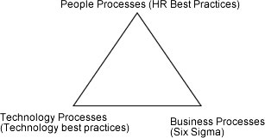
B) Business Processes:
Six Sigma Framework
EGFL focuses has rolled out six sigma across the entire organisation and build capability within the client organisation to take forward the initiative on their own. This engagement includes training, certification of people and hand holding during implementation across critical business processes of the organisation. The engagement is further strengthened with EGFL surround methodologies of Knowledge management, Program management, monitoring and participation in turbo projects. EGFL approach is quantitative and can reduce the cost of quality as measured as % of sales.
Six- Sigma has brought in:
- Continuous defect reduction in products/services
- Focus on performance metrics
- Measurable milestones.
- Sustainability
Implementation of Six Sigma has also resulted in Integrated Business Process
Improvement in EGFL:
This involves improvement of process efficiencies followed by process automation. This approach has benefited from a robust change management program. Today, EGFL applies best in class tools, methodologies in a systematic way. This provides measurable milestones that can be presented to those involved and stake holders. A robust process thus becomes suited for process automation. It can serve as bedrock to move to higher level of building capabilities.
Technology Process:
Implementation of Six Sigma as transformed the technology process as from being support functions. Information Technology departments are now being 12rganizati as business enablers. The key to this transformation is robust processes that add value to the 12rganization and at the same time provide practices in the evolving market place. Robust practices cover both internal functional areas as well as external value chain comprising customers and suppliers.
EGFL offers practices to optimize and standardize various processes in line with frameworks. EGFL offers gap analysis with reference to the frameworks, defines IT processes covering policy, processes and performance metrics. EGFL value is in the implementation support and plan for development of detailed specifications, deployment of policies, tools and procedures.
People Process:
Also with the help of Six Sigma, EGFL people process practice complements their business process and technology process services. EGFL employs robust methodologies, practices and tools to improve people processes covering:
Basic Process:
- Staffing: In EGFL the number of full time personnel devoted to Six Sigma is not large. Mature Six Sigma program has about one Master Black Belts for every ten Black Belts. A Black Belt typically completes 5 to 7 projects per year. Project teams are lead by Green Belts, who, unlike Black Belts and Master Black Belts, are not employed full time in the Six Sigma program. Black Belts are highly prized employees and are often recruited for key management positions elsewhere in the company. After Six Sigma has been in place for three or more years, the number of former Black Belts tends to be about the same as the number of active Black Belts.
- Training and Development
- Performance management systems.
2) RECOMMENDATIONS
Figure 2.2: 10 Critical Success Factors
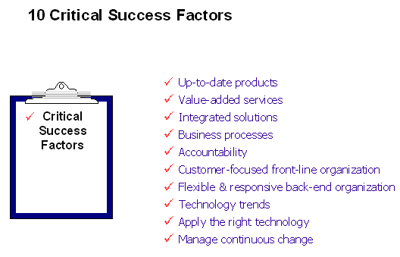

In assisting to the clients over the years, Essar Global identified the following 10 critical success factors that must be addressed to stay ahead of the game (Refer to Figure 2.2):

1. Up-to-Date Products
It sounds obvious, but keeping your product offerings up-to-date in this day and age is a challenge. The changing market requirements and expectations, intensifying competition, and continual advances in new technology are all drivers that lead toward both the need - and ability - to embed commensurate change in our products in order to remain attractive to our customers over time. Regardless of which industry segment you serve, we have seen product life cycles decline dramatically over the last couple of decades. The implication of this trend is that you will need to maintain a continuous effort to improve and upgrade your products over time to ensure that you consistently meet your customers' expectations. However, in order to do this effectively, you will need to be able to anticipate what your customers' expectations will be at the end of your development cycle - and this may be difficult, as the general rule of thumb is "the shorter the cycle, the easier it is to anticipate your customers' expectations".
Therefore, it is critical to analyze and forecast your emerging markets to minimize the risk of launching new and/or enhanced product lines that may not satisfactorily address your customers' needs. However, the risks may be significantly reduced by conducting the appropriate market analyses, customer surveys, focus groups, and competitive business intelligence.
2. Value-Added Services
Most products, especially the more complicated ones, neither sell nor work by themselves, and require additional levels of service and support in order for customers to benefit from their full use and application. This may include anything from routine maintenance and customer technical support, to customization and application training. This trend in the high-tech services industry is decades old, and yet, many organizations have not yet made a complete transition to the "new" way of providing total customer support.
Thus, an organization's value-added services need to be focused on the specific needs of its customers, in conjunction with the technical specifications and requirements of the products. If done correctly, the total results in earned revenues and profits will be more than equal to the sum of the two individual components. However, this requires an in-depth knowledge within the organization of not only the technical applications and uses of the products, but also the specific needs of the customers with respect to their day-to-day operations. This may involve customization where necessary; consulting and applications training for the more complex uses of the systems and equipment; and the appropriate levels of user training and documentation to support the customers following the installation.
3. Integrated Solutions
In most cases, it may be assumed that the customer is not so much interested in the technical nature of the product, but rather in the solution it provides for his or her tasks-at-hand. It is important to recognize that in the customer's mind, if the product is not working optimally, regardless of the technology, it is "worthless". Conversely, it is the totality of the solution that the product provides that is most important to the customer. This may involve any and all aspects relating to the product, including connectivity, customization, reliability and (not necessarily the least), training of the operators and support for the maintenance personnel, if applicable.
For example, in the early days of network support, where multiple parties were responsible for individual pieces of the total "pie", there was a great deal of finger pointing whenever the system was not working or would go down, but not much certainty as to whom was really accountable for any particular incident. In these types of situations, the solution typically focused not only on the product and service delivery, but on the overall system maintainability as well. As a result, uptime and performance guarantees during the overall life cycle of products have become common requirements nowadays, typically requiring sophisticated solutions for total service and support including remote diagnostics and self-service via Internet technology, etc. For these reasons we, as an industry, have to make sure that these total requirements are always considered in the final specifications of the products and services we offer, and are fully integrated into the customer systems we support.
4. Business Processes
In order to be able to effectively deliver the products, services, and solutions that our customers need, we also need to ensure that the business processes we utilize are appropriate, up-to-date, and that they get the job done. If they are not, then we need to change them where necessary to meet our customers' expectations without creating an overly-costly solution that effectively eliminates our profit margins. In assessing business processes, it is important to understand that selling products is fundamentally different from selling services and solutions, thereby requiring totally different approaches, processes, and skills. As service and support offerings continue to be enhanced in order to provide customers with more comprehensive solutions, the processes that are required also continue to change, and require different and more sophisticated skills and tools, themselves. In many cases, services specialists need to be included in the mix, due to the complexity of the desired solutions.
One of the most significant customer requirements that must be addressed in the business processes is the time factor. Next-day service is increasingly perceived by customers as "too slow" at best, and in some customer environments, completely "unacceptable". The requirement for same-day service remains a challenging factor, especially if the complexity of the solution is "high" and the density of the installed base is "low". However, technology can provide a solution to this issue through the use of remote diagnostics and web-based self-support, where possible, without breaking the bank - for either the customer, or the service provider. But, meeting this need generally requires some primary customer research, internal process assessment and, possibly, a fundamental re-design of the existing business processes and tools used, conditioning the customer, solution training, and a communication structure that allows for real-time escalation.
5. Accountability
As solutions and processes become more complex, it also becomes more likely that multiple people get involved at different stages along the way. Although technology can help manage this to some extent, there is still a big risk that something may go wrong, or may fall "between the cracks". To avoid these possibilities requires a different approach and - more importantly - a different attitude. The presence of any "not my job" attitude among existing personnel would be devastating in this kind of an environment. To have any chance for success requires teamwork, accountability, and follow-through, and the organization will need to make sure that it not only designs the business processes to allow for direct accountability, but that it also configures the automation systems to support it. Some companies have successfully implemented team efforts and accountability, deep within the organization via account teams that are dedicated to "taking care of the customer" versus merely "taking care of the problem". It is our experience that to implement this takes a great deal of time, and requires specific training in different skill sets, team building, and influencing the attitudes of people.
6. Customer-Focused Front-Line Organization
Since the customer should always be the main focus of the company, we need to make sure that the organization is structured appropriately to provide this focus. The most important interfaces with the customer are typically made through the Sales and Services parts of the organization, as they are in direct contact with the customer all of the time, either in person or over the phone. The way they interact with customers will ultimately determine the customers' perceptions of the organization as a whole. This means that the skill sets that are required must not only cover the technical aspects of customer support, but also the communications and interpersonal skills that let customers know that they are being cared for properly. This is especially true for an organization that is in transition (i.e., in growth mode, recently merged, start-up, retrenching, etc.).
It is our experience that most personnel can always use some additional training to hone their existing skills and make them more aware of the specific "do's and don'ts" of customer interaction. By creating (or refining) customer-focused, integrated processes, we can adapt the organization to meet its customers' emerging needs, formalize the internal responsibilities for taking care of the customer, and reduce all other duties that could take the attention away from the organization's customer focus (e.g., miscellaneous administrative duties, etc.). By doing this effectively, the organization may focus all of the necessary attention to the customer, thereby greatly increasing its chances for success
7. Flexible and Responsive Back-End Organization
However, to allow the front-line personnel to focus directly and effectively on customers, the organization will also require a flexible and responsive back-end organization. This part of the organization needs to be able to support its front-line personnel through the development of the tools and methods that enable the proper execution of the required tasks. This includes the formal documentation of the technology utilized, the instructions and guidance for applying it, the development of selling and maintenance tools, and, last but not least, a specific set of escalation procedures.
The back-end organization is responsible for setting the stage and creating an infrastructure that allows the front-line organization to perform its tasks without hassle or interference. Functions in this segment of the organization may include, sales support and administration, technical and product support, training, and logistics functions. Despite the fact that these functions are typically more internally and product focused, they are still important factors that affect customer perceptions. We have seen in many organizations a lack of the sense of urgency and responsiveness in the back-end organization that ultimately affects the ability of the front-line organization to provide customers with the levels of performance that they require.
8. Technology Trends
Technology is one of the key elements for change, and can provide us with most of the tools we need to improve our business performance, as well as lowering the operational costs of the organization as a whole. We all know the rallying call to "do more with less" and, in most cases, technology, if applied correctly, is the principal tool that will allow us to do so. The real challenge, however, is to determine what is realistically available, and how we can best use it to our benefit. We have all seen the hype in various articles and advertisements that promotes "new" technology products; but we have to realize that some of these "new" technologies, despite the promise, are not yet mature - or truly available.
For example, advertisements like "can you hear me now" clearly indicate that we still have problems with wireless coverage. Accordingly, if you base your communication and information flows solely on wireless technology, you might be in for some surprises. However, this does not necessarily mean that we should not investigate this technology further, and continue to pursue this direction. The potential is there and the existing limitations are likely to disappear over time, allowing us to take full advantage of these - and related - technologies to improve our businesses, as well as our ability to support the products, services and the business processes that are required to deliver them.

3) SIX SIGMA FOR SMALL AND MEDIUM SIZED BUSINESSES & LARGE BUSINESSES:

All companies can save money by reducing the causes of defects in products, deficiencies in services and processes, and by improving sales through greater customer satisfaction. However, a small company (less than 100 employees) will have fewer resources available than a larger company (1000 employees) to complete projects. The magnitude of improvement will be different between large and small companies. A small company also may have a lesser need to improve than a larger company. Small companies have fewer employees wearing "multiple hats" when carrying out tasks in a process. With fewer employees involved there may be fewer deficiencies to improve on. A larger company will have multiple employees and functions involved, creating complexity and possibly a greater amount of deficiency in the processes.

The main difference between small and large companies will be how to train employees in the tools and techniques of Six Sigma. The short term costs for training and the length of time to complete projects may take longer than in a large company. This mainly occurs because smaller companies cannot free up too many individuals in a short period of time to make the improvements.
One of the more familiar dilemmas in business today is how to implement Six Sigma in small and medium-sized companies. This is a serious issue because larger companies are beginning to mandate Six Sigma to their supply base as a condition of doing future business. The problem arises when small and mid-sized organizations solicit deployment proposals from Six Sigma consulting companies only to learn that the traditional Six Sigma implementation approach can require millions of dollars in investment, dedication of their best full time resources, and training of the masses. Those of you who have experienced this situation will agree that this approach to Six Sigma is unrealistic for smaller and mid-sized organizations. But there still exists a real need to bring smaller and mid-sized companies into the Six Sigma fold, because collectively they might represent as much as 75%-80% of total value stream activity.
The traditional top-down implementation approach is a major barrier to entry for smaller and mid-sized companies, and it doesn't need to be. There are alternative Six Sigma deployment models that allow smaller and mid-sized organizations to implement at a pace where they can actually digest the methodology and achieve benefits, without the significant resource commitment and overhead structure of the traditional Six Sigma implementation approach. As a result, organizations are sometimes able to achieve faster and more impressive benefits than their larger customers.
One Size Fits All? -- NOT!
One observation I've made about the Six Sigma implementation lifecycle is that the majority of benefits are not derived from Black Belts - they are generated at the Green Belt and Yellow Belt level, especially when the Six Sigma process becomes institutionalized. Another observation is that Black Belts and Green Belts are interchangeable for about 80% of the organization's Six Sigma opportunities. Using a Green Belt and Yellow Belt approach addresses many of the constraints of smaller and mid-sized companies and allows them to implement at a more manageable pace. These organizations become just as technically skilled as their larger company counterparts; in fact, many are outperforming their larger customers in terms of both financial results and cultural transformation.
Scaleable Six Sigma - How It Works
Below is a brief 8-step process overview of a Six Sigma deployment and execution process I recommend for smaller and mid-sized organizations:
- A Six Sigma strategy and overarching infrastructure is developed. The strategy, implementation approach and projects are directly aligned to the organization's strategic plan and customer requirements. This step also includes well-organized communication and awareness building for Six Sigma.
- Implementation planning is completed. Beyond the overall program, this includes defining objectives, scope, goals, priorities, work plans, deliverables, baseline performance, and expected performance/financial improvements for a pool of high-impact Six Sigma projects.
- Team formation and the education plan begin concurrently. The Six Sigma strategy definition and implementation planning provides background and focus for the teams, and prevents wasted time and resources debating over what needs to be done. In addition, education is customized to business specific needs and includes sample issues, data, and examples from their actual processes.
- Executives complete Champion education where they learn about the Six Sigma process, methodology, and tools. Executives also focus on how to lead, structure, and mentor a successful Six Sigma effort through several exercises. Although the Six Sigma approach is different in smaller and mid-sized companies, Executives must understand that Six Sigma still requires the same leadership and commitment as in larger companies.
- Selected individuals complete Green Belt certification (e.g., a group of 25 individuals over a 2-3 month period). This education focuses on Six Sigma but it includes and integrates Kaizen and Lean. I believe a program should stress deployment of the right tools to the right opportunities, because not all problems require a complex statistical approach.
- Other team members complete Yellow Belt certification (e.g., 25-50 individuals over a 2-4 week period). This education focuses on the basic "blocking and tackling" tools of Six Sigma, as well as Kaizen and Lean.
- Later in the lifecycle, individuals are transitioned to the next level of Six Sigma achievement. Some selected Green Belts are developed into Black Belts, and some Yellow Belts are developed into Green Belts. Other new resources are developed into Green Belts and Yellow Belts respectively based on need. The goal is to ramp up to a point where the tangible savings is funding the Six Sigma program.
- In all cases, certification is by achievement, not attendance. Beyond the classroom time, all certification candidates must complete a mandatory project that demonstrates the correct deployment of Six Sigma, solves a real business problem and achieves a targeted savings.
The above building-block approach can be modularized so that the organization can quickly transition their Six Sigma resources to the next highest level of achievement. Additionally, they can accomplish their Six Sigma implementation at a more manageable pace and scope. The number of projects, the levels of education, and the whole deployment and execution approach occur at a digestible pace, with a direct link to strategy and results.
There Is A Better Way
This above type of scaleable approach to Six Sigma enables smaller and mid-sized organizations to achieve results at a more manageable pace, while still achieving desired results. The "one size fits all" Six Sigma deployment model just isn't practical for every company or organization, and other deployment models should be explored. The real need to bring smaller and mid-sized companies into the Six Sigma fold can be satisfied with the right deployment model.

Six Sigma Deployment

Leadership
Six Sigma involves changing major business value streams that cut across organizational barriers. It is the means by which the organization's strategic goals are to be achieved. This effort cannot be lead by anyone other than the CEO, who is responsible for the performance of the organization as a whole. Six Sigma must be implemented from the top-down.

Champions and Sponsors
Six Sigma champions are high-level individuals who understand Six Sigma and are committed to its success. In larger organizations Six Sigma will be lead by a full time, high level champion, such as an Executive Vice-President. In all organizations, champions also include informal leaders who use Six Sigma in their day-to-day work and communicate the Six Sigma message at every opportunity. Sponsors are owners of processes and systems who help initiate and coordinate Six Sigma improvement activities in their areas of responsibilities.
Champions have a much larger role in deploying Six Sigma or any other initiative than just removing roadblocks. The job requires more than just this single task. Champions must be integrated into the business, select projects accurately, adjust the speed of the deployment as necessary, and take responsibility for implementation.
Unless metrics are placed on all responsibilities of a Champion, the organization is placing the deployment at risk. Failure to execute these tasks at even a minimal level can and does propagate turnover of the people your organization spent valuable resources training.
I. Top 10 Tips for Managing Six Sigma
- Leadership/top management commitment is essential. Secure the Top management commitment by first training them. This training should consist of an introduction to Six Sigma, tools and techniques used, and the roles and responsibilities of the management as Champions. The Leadership team has to be totally convinced of the benefits of Six Sigma. In addition, executive management should form a Steering Committee which will now ensure that:
  - Organizational goals are aligned with Six Sigma projects
  - Resources are planned for and roadblocks removed
  - A person to lead this effort in the organization is selected. S/he will be trained as a Black Belt and will report to the Steering Committee. They must select their best performing person for this job.
- All leaders should be trained as Six Sigma Champions. This is normally a 2-day training session that ensures that the Champions learn to ask the right questions of Six Sigma practitioners. This group includes the Steering Committee, process owners, and functional managers (like Production Manager, Maintenance Manager, etc.).
- Include Six Sigma planning within the business-operating plan. Ensure the when the Operating Plan for the next year(s) is being made, Six Sigma Project savings become an input for that plan.
- Select the right consultant to train your Belts. There are a lot of mediocre programs floating around being offered even by reputed training institutions. One point to remember is that you will be best trained by a Six Sigma practitioner (Black Belt or Master Black Belt) rather than an academic who will teach you only theory. A typical Black Belt training program is spread over 4-5 months, and a Black Belt will need to complete two projects before s/he is certified (which will typically take longer than 6 months). A Green Belt training program is spread over 4 months and requires one project for certification. At Owens Corning I have designed the White Belt (3 day) training program to help employees on the shop floor lead their own projects (though smaller in size and duration).
- Ensure that the Return On Training Investment is at least 20 times. This can be done by good project definition and correct practitioner allocation.
- Gets the movement going at the shop floor level. Rather than having a few Black Belts or Green Belts doing projects all the time, train shop floor operators and supervisors in the use of tools and techniques (White Belt program). This way the ownership is theirs and they are doing the improvements on their own. Reward well the project leaders and their team members when they receive certification. Make it such that other people aspire to get this certification. The certified candidates should be adequately compensated during their annual performance review.
- Create a certification process. Ensure that the certification process is rigorous and true. This will ensure that only after successful completion of projects and demonstrating proper use of tools/techniques, the practitioner candidate will get certified. The Functional Area Manager, Finance Leader and Six Sigma reviewer should sign on the certificate declaring that the benefits have actually started accruing.
- Develop a mentoring process. Ensure that proper guidance/handholding is being done by experienced practitioners for the new candidates after their training. This will ensure that the course corrections are made regularly and the projects get completed on time.
- Ensure financial validation of projects. Make sure that the Finance Leader is signing off on the project's actual savings. The finance department should do the reporting of the metrics and savings in the control phase of the projects. The project metrics should continue to be tracked after the project is declared completed. This tracking responsibility should be on the project leader or process owner if handed off by the project leader.
- Never allow Six Sigma to be classified as a Quality Manager's job. A Quality Manager's role is distinct and s/he will not be in position to manage the Six Sigma process as for the entire business.
Future of Six Sigma: The New Focus
Six sigma is a business initiative that helps the organization meet its changing business need.
It is widely used to provide a structured approach to improve process but many organisations have found that the return of an organization's effort will be much more favorable to the "bottom line" if the six sigma methodology was focused on the design and not the product alone. Although six sigma brings a new direction to quality and productivity improvements, its underlying tools and philosophy are grounded in the fundamental principles of total quality and continuous improvement that have been used for many decades.
Over the past few decades Six Sigma has evolved from a focus on defects to cost reduction to value creation. In its initial application, Six Sigma delivered defect reduction. Then over a period of time organization started using Six Sigma extensively to achieve cost reduction. The latest iteration, Six Sigma Generation III, delivers higher levels of value for the customer and provider.
Six Sigma creates value by focusing everyone on a simple, but highly effective four-step strategy - Innovation, Configuration, Realization and Attenuation. In terms of product or service value, there are three key determinants. First, there is utility (form, fit and function). Second, we have Access (volume, timing and location). Third, we must consider the idea of Worth (economic, emotional, and intellectual). Put it all together and we have the guiding principle that value, is delivering a quality product or service to the proper location, at the right time, in the right volume, at the lowest possible cost.
For every product or service, an enormous number of expected value requirements exist. These requirements are referred to as critical-to-value characteristics, or simply CTV's. And for every rightful level of expectation, the actual condition exists. This creates a value gap between the value expectation and the value reality. Six Sigma projects are undertaken to close every one of the value gaps, whether it is focused on product or process design, economic value, manufacturing or any other factor.
With the change in the application focus Six Sigma delivers additional value by reducing the gap between the customer's expectations and what the provider delivers. It does this by uncovering hidden sources of loss - in processes, products and services.
The drivers of Six Sigma for value creation include small to mid size companies that must improve performance and profitability to continue operating. The advanced e-technologies of the Internet now allows classroom-like training online, reducing training and related expenses. Ultimately, it will be the need of all companies small or big to improve profitability and Six Sigma professionals to improve career opportunities that will drive the new generation of Six Sigma.

II. OPINION ON SIX SIGMA
Six sigma is powerful approach achieve breakthrough improvements in manufacturing, engineering and business processes. The approach relies heavily on advanced statistical methods that complement the process and product knowledge to reduce variation in processes. It is new way of doing business that would eliminate the existing defects efficiently and would prevent defects from occurring. Different strategies are used by organizations to introduce and deploy six-sigma approach. Each of these strategies has advantages and potential failure modes that must be addressed and avoided.
This approach of reducing defects in corporations has made a stunning resurgence thanks to highly publicized successes, such as the claim by corporate icon General Electric Co. that Six Sigma cut $1.5 billion from its costs last year. By some estimates, more than a quarter of the Fortune 200 roster of big companies have Six Sigma projects under way. It is the methodology’s success that has led practitioners to greatly expand how it is used. While Six Sigma initially was applied primarily to manufacturing and logistics, it now can be applied to “all industries and all functions. Six Sigma can even be used in research and development to find innovative products some companies view it as an enterprise wide business strategy. Six Sigma’s proponents acknowledge that problems can arise, but they say the problems relate to bad implementation rather than to the methodology itself. Proponents say difficulties may stem, in particular, from a lack of commitment from senior management or from a lack of patience.
On the flip side we have found many others aren’t so sure. While acknowledging that Six Sigma is great in some uses, they say the system assumes that what exists is fundamentally sound and merely needs refinement. As a result, critics charge, Six Sigma is ill-suited for developing innovative products, finding fundamentally new internal processes, or setting overall corporate strategy. Consulting firms often need to relearn the truism that once you master a hammer, everything starts to look like a nail The recent trend to use Six Sigma statistical process-control metrics for every damn fool thing is just the latest example of the adaptive instincts of modern consulting. The use of Six Sigma also failed to help IBM spot a strategic fiasco in its personal-computer business. The business was using the Six Sigma methodology to improve its forecasts for consumer demand when the right approach would have been to do away with the forecasts. As rival computer maker Dell Computer Corp. has shown, it is far more efficient to wait until a consumer orders, before building the computer. Because IBM just made incremental changes to the wrong approach, it posted losses of as much as $1 billion a year in the PC business in the 1990s and ultimately abandoned the consumer part of the market. Even when a company is happy with Six Sigma, results don’t always match expectations. Six Sigma projects are measured on whether they speed up and improve processes or increase customer satisfaction not on savings. Savings don’t enter into the equation. There are much cheaper cost-reduction programs than Six Sigma, which is a very training-intensive program that takes years for a company to internalize.

CHAPTER 4
METHODOLOGY

THEORETICAL PERSPECTIVE
Six Sigma is a term used to describe a measure of quality control that is higher than "normal". Six Sigma at many organizations simply means a measure of quality that strives for near perfection. Six Sigma is a disciplined, data-driven approach and methodology for eliminating defects (driving towards six standard deviations between the mean and the nearest specification limit) in any process -- from manufacturing to transactional and from product to service.
It is a measure of quality that strives for near perfection. The Six Sigma process uses data and rigorous statistical analysis to identify "defects" in a process or product, reduce variability, and achieve as close to zero defects as possible.

THE GENESIS AND HISTORY OF SIX SIGMA
The roots of Six Sigma as a measurement standard can be traced back to Carl Frederick Gauss (1777-1855) who introduced the concept of the normal curve. Six Sigma as a measurement standard in product variation can be traced back to the 1920's when Walter Shewhart showed that three sigma from the mean is the point where a process requires correction.
Since the 1920's mathematicians and engineers have used the word ‘sigma’ as a symbol for a unit of measurement in product quality variation. In the mid-1980's engineers in Motorola Inc in the USA used 'Six Sigma' as an informal name for an in-house initiative for reducing defects in production processes, because it represented a suitably high level of quality In the late-1980's following the success of the above initiative, Motorola extended the Six Sigma methods to its critical business processes, and significantly Six Sigma became a formalized in-house 'branded' name for a performance improvement methodology, i.e., beyond purely 'defect reduction', in Motorola Inc.
In the early and mid-1980s with Chairman Bob Galvin at the helm, Motorola engineers decided that the traditional quality levels -- measuring defects in thousands of opportunities -- didn't provide enough granularity. Instead, they wanted to measure the defects per million opportunities. Motorola developed this new standard and created the methodology and needed cultural change associated with it. Six Sigma helped Motorola realize powerful bottom-line results in their organization - in fact; they documented more than $16 Billion in savings as a result of our Six Sigma efforts.
Since then, hundreds of companies around the world have adopted Six Sigma as a way of doing business.

I. Chronology of Events
The entire genesis and history of Six Sigma can be explained with the chronology of events that are given as follows:
Table 4.1: History of SIX SIGMA
YEAR | EVENT
1777-1855 | Introduction of the concept of normal curve by Carl Federick Gauss
1920 | Use of the word ‘sigma’ as symbol by mathematicians
1980’s | 1980's engineers in Motorola Inc in the USA used 'Six Sigma' as an informal name for an in-house initiative for reducing defects in production processes
1991 | Allied Signal, (a large avionics company which merged with Honeywell in 1999), adopted the Six Sigma methods, and claimed significant improvements and cost savings within six months
1995 | General Electrics introduced the concept of six sigma in their company.
1998 | 1998 General Electric claimed that Six Sigma had generated over three-quarters of a billion dollars of cost savings.
2000 to Present | Six Sigma was effectively established as an industry in its own right, involving the training, consultancy and implementation of Six Sigma methodology in all sorts of organizations around the world.
[Reference to https://www.sixsigma-institute.org/History_Of_Six_Sigma.php]
That is to say, in a little over ten years, Six Sigma quickly became not only a hugely popular methodology used by many corporations for quality and process improvement, Six Sigma also became the subject of many and various training and consultancy products and services around which developed very many Six Sigma support organizations.

II. THE CONCEPT OF SIX SIGMA
Six Sigma is a data-driven quality measure that strives for a near perfection of any process. It is important to understand Six Sigma as a tool, as too many incomplete definitions have made it look like a complicated fad.
Six Sigma focuses on improving quality (i.e. reduce waste) by helping organizations produce products and services better, faster and cheaper. Six Sigma focuses mainly on defect prevention, cycle time reduction, and cost savings. Unlike mindless cost cutting programs, which reduce value and quality, Six Sigma identifies and eliminates costs, which provide no value to customers and the production process. To understand the concept of Six-Sigma one must understand the concept of normal curve.
Normal Distribution Curve
The normal distribution curve is a symmetrical Bell shaped graph representing the distribution of a data set. The bell-shaped curve results when a normal distribution is represented graphically by plotting the distribution f (x) against x. The curve is symmetrical about the mean value.
Normal curve features:
- Normal distributions are symmetric around their mean.
- The distribution has two parameters, mean (µ, mu) and standard deviation (σ, sigma)
- The mean, median, and mode of a normal distribution are equal.
- 68% of the area (data points) lies within one standard deviation (+/-1 sigma) of the mean.
- 95% of the area (data points) lies within two standard deviation (+/-2 sigma) of the mean.
- 99.7% of the area (data points) lies within three standard deviation (+/-3 sigma) of the mean.

A normal distribution exhibits the following:
Table 4.2: Shows the Normal Distribution as discussed above

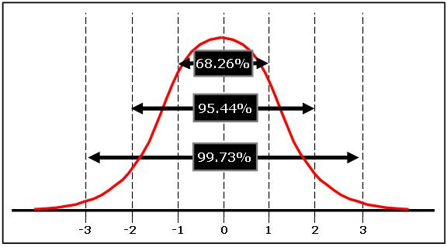
[Reference http://www.six-sigma-material.com]
Before Six-Sigma methodology came in vogue, 3 sigma tolerance levels (for any process) used to be the benchmark for quality measurements. But Motorola engineers argued that a process could shift 1.5 sigma in regular course, as shown in the figure below. Now, to keep the data points within earlier permissible area, with mean shifting by 1.5 sigma, the sigma level has to be half. Thus, to accommodate 1.5-sigma shift, they proposed that the tolerance has to be +/- 6 sigma. In six-sigma methodology 99.9996599% (or more) of process data lies within +/- six sigma from the mean, thus having only 3.4 defects per million opportunities (DPMO). Now, 99.9996599% value is actually for 4.5 sigma level in Normal curve, but keeping in view the 1.5 sigma process shift, the process sigma level is actually six.

Six Sigma Conversion Table

YIELD (%) | DPMO | SIGMA |  | YIELD (%) | DPMO | SIGMA
6.6 | 9,34,000 | 0 |  | 94.5 | 54,800 | 3.1
8 | 9,20,000 | 0.1 |  | 95.5 | 44,600 | 3.2
10 | 9,00,000 | 0.2 |  | 96.4 | 35,900 | 3.3
12 | 8,80,000 | 0.3 |  | 97.1 | 28,700 | 3.4
14 | 8,60,000 | 0.4 |  | 97.7 | 22,700 | 3.5
16 | 8,40,000 | 0.5 |  | 98.2 | 17,800 | 3.6
19 | 8,10,000 | 0.6 |  | 98.6 | 13,900 | 3.7
22 | 7,80,000 | 0.7 |  | 98.9 | 10,700 | 3.8
25 | 7,50,000 | 0.8 |  | 99.2 | 8,190 | 3.9
28 | 7,20,000 | 0.9 |  | 99.4 | 6,210 | 4
31 | 6,90,000 | 1 |  | 99.5 | 4,660 | 4.1
35 | 6,50,000 | 1.1 |  | 99.7 | 3,460 | 4,2
39 | 6,10,000 | 1.2 |  | 99.75 | 2,550 | 4.3
43 | 5,70,000 | 1.3 |  | 99.81 | 1,860 | 4.4
46 | 5,40,000 | 1.4 |  | 99.87 | 1,350 | 4.5
50 | 5,00,000 | 1.5 |  | 99.9 | 960 | 4.6
54 | 4,60,000 | 1.6 |  | 99.93 | 680 | 4.7
58 | 4,20,000 | 1.7 |  | 99.95 | 480 | 4.8
61.8 | 3,82,000 | 1.8 |  | 99.97 | 330 | 4.9
65.6 | 3,44,000 | 1.9 |  | 99.977 | 230 | 5
69.2 | 3,08,000 | 2 |  | 99.985 | 150 | 5.1
72.6 | 2,74,000 | 2.1 |  | 99.99 | 100 | 5.2
75.8 | 2,42,000 | 2.2 |  | 99.993 | 70 | 5.3
78.8 | 2,12,000 | 2.3 |  | 99.996 | 40 | 5.4
81.6 | 1,84,000 | 2.4 |  | 99.997 | 30 | 5.5
84.2 | 1,58,000 | 2.5 |  | 99.998 | 20 | 5.6
86.5 | 1,35,000 | 2.6 |  | 99.999 | 10 | 5.7
88.5 | 1,15,000 | 2.7 |  | 99.9992 | 8 | 5.8
90.3 | 96,800 | 2.8 |  | 99.9995 | 5 | 5.9
91.9 | 80,800 | 2.9 |  | 99.99966 | 3.4 | 6
93.3 | 66,800 | 3

In Six-Sigma process, 99.9996599% data will be within +/- 6 sigma levels, which is a -total of 12 sigma under the curve. To have a six-sigma process, 12 standard deviations should be able to fit in the permissible spread (customer specification limits). Let’s look at few terms:
LSL = lower specification limit
USL = Upper specification limit
Permissible Spread under the curve = USL - LSL
In Six-Sigma, we can conclude:
12*standard deviation (sigma value) = Permissible spread under the curve
Here’s a practical example:
The customer wants cloth of thickness 1mm +/- 0.001 mm, so the customer wants between 0.999 mm to 1.001 mm thickness.
LSL = 0.999 mm, USL = 1.001 mm
Permissible spread = USL – LSL = 0.002
Since, 12*standard deviation (sigma value) = Permissible spread under the curve so standard deviation (sigma value) = (0.002)/12 = 0.000167 for a six sigma process.
It is a highly disciplined approach used to reduce the process variations to the extent that the level of defects are drastically reduced to less than 3.4 per million process, product or service opportunities (DPMO). The approach relies heavily on advanced statistical tools. While these tools have been known earlier, these were primarily limited to the statisticians and quality professionals. Sigma is Greek letter that is used to describe variability. In statistical quality control, this means "standard deviation". Most of us may be familiar with the normal distribution and its properties. We are aware of the properties of normal distribution:
99.73% of the area lies within mean m ± 3 sigma
95.46% of the area lies within mean m ± 2 sigma
68.26% of the area lies within mean m ± 1 sigma
When we proudly mention that our process capability Cp is 1.33, our process spread is ± 4 sigma. This would mean and estimated defect rate of 0.0063% or 63 defective parts per million (PPM). Moreover, when we deploy processes in production, the mean of the process can shift to the extent of approximately 1.5 sigma. In such case the defect rate will increase to a much higher value. This would be about 6200 PPM! If the process capability is improved to a Cp of 2.0 the PPM level will come down to 0.002. With a shift of 1.5 sigma, the Cpk will drop down to 1.5 and the number of parts defective will be about 3.4 PPM. A Cp of 2.0 corresponds to the process spread of ± 6 sigma. This is shown in the figures (3.2 ) below

Figure 4.3: With a shift of 1.5 sigma, the Cpk will drop down to 1.5 and the number of parts defective will be about 3.4 PPM
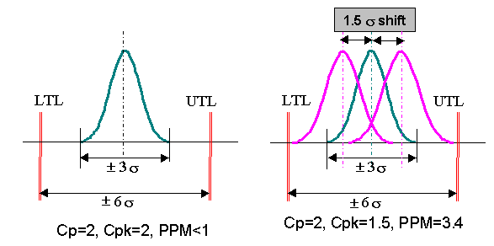
[Reference: https://dhanushkarthikeyan.wordpress.com/2014/09/15/six-sigma-dmaic-methodology/]
Let us consider an example of an assembly with 30 parts and 5 steps. This means that there are 30x5 or 150 opportunities for a defect to occur. If we find that there are 100 defects in every 100 assemblies. This means one defect per assembly or 1 million defects in one million assemblies. This can be converted to 1000000 x (1/150) or 6666 defects per million opportunities (DPMO). This approximately corresponds to a sigma level of 3.97.
Refer to the following table for relation between sigma quality level and PPM. The PPM values are calculated considering a shift of 1.5.

Figure 4.4: PPM values calculation as discussed below
Specification LIMIT | Percentage inside Specification | Defective (in PPM)
± σ (Sigma) | 30.23 | 697700
±2 Sigma | 69.13 | 608700
± Sigma | 93.32 | 66810
± Sigma | 99.3790 | 6210
± Sigma | 99.97670 | 233
± Sigma | 99.999660 | 3.4

[Reference:https://www.researchgate.net/figure/Percentage-distributions-of-data-with-15-shift_tbl1_272742514]
- Another concept that is used as a metric in six sigma is Rolled Throughput Yield (RTY). Let us assume that a part goes through ten operations. At each stage 99% parts are good and 1% are reject. It is not very difficult to calculate that we get good 90.43 % parts at the end of the tenth stage. This means if we start with a batch of 1000 parts, we get 904 good parts and scrap or rework 96 parts. The RTY of the process is 90.43%.
- Balance Score Card
The Balanced score card perspectives help an organization to integrate and operationalize the organizations strategy.

Figure 4.5: Showing the Balanced Score Card
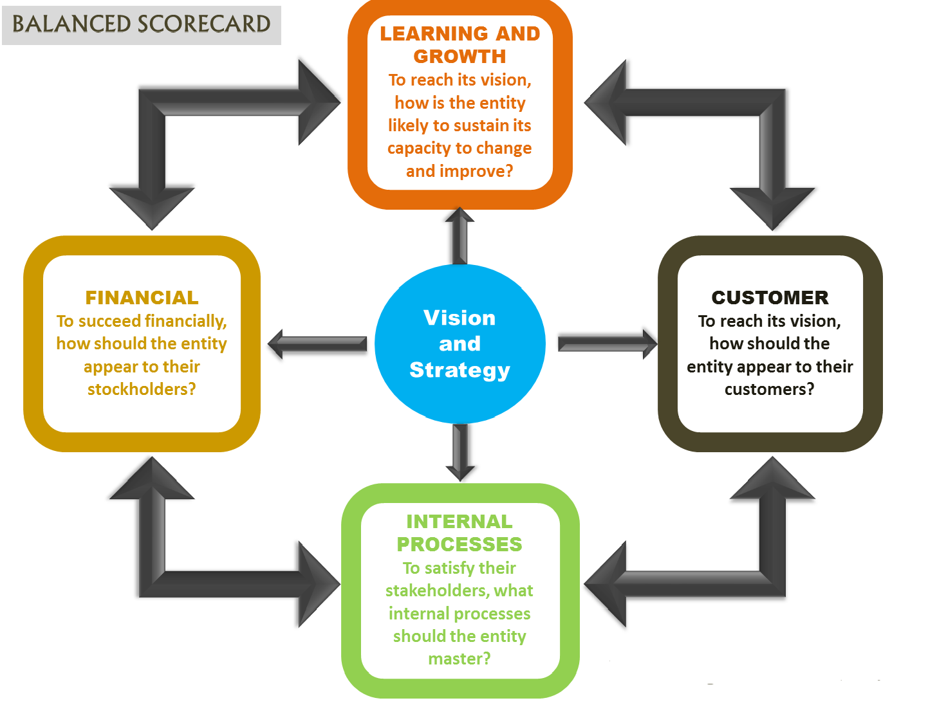
The Balanced Scorecard Institute says that it is “a strategic planning and management system that is used extensively in business and industry, government, and nonprofit organizations worldwide to align business activities to the vision and strategy of the organization, improve internal and external communications, and monitor organization performance against strategic goals.”

Developed by Dr. Robert Kaplan and David Norton, this approach draws heavily from the pioneering work done in General Electric back in the 1990s that changed the way companies looked at factories, supply chains and business statistics.
What used to be a simple way to categorize feedback and give numerical value to actual business growth in several aspects, the balanced scorecard approach is now a full strategic planning and management system.
1 – If you want to know more about balanced scorecard, here are the top 5 things you must always keep in mind:
It is a management tool. While it’s easy to assume that this approach to management has everything to do with measurement, it’s still rooted in the fact that the metrics serve only as a tool to manage your team or business. Numbers are involved when you set, track and achieve the business strategies that you are employing.
It’s made up of four legs, like a race. These four legs comprise four distinct business perspectives: The Customer Leg, the Financial Leg, the Internal Business Process Leg and the Knowledge, Education and Growth Leg.
Customer leg : This leg measures your customer’s satisfaction and their performance requirements. This requires you to look for the critical features your customers want to see in your product or service and if you can deliver it in a timely and expected manner.
Financial leg : This leg deals with the financial matters of your company and how you’ve grown in terms of hard numbers since you began the balanced scorecard approach. This can look at sales, revenue, spending and any other financial figure that you want to measure to improve your company.
Internal business process leg: This measures your critical-to-customer process requirements and measures. While your customers aren’t really concerned with how they get their products and services, this leg manages and tracks how your supply chains, assembly and other internal processes work to get products rolling off to clients.
Learning and Growth Leg (Knowledge & Education): Focuses on how you educate your employees, how you gain and capture your knowledge, and how you use it to maintain a competitive edge within your markets. This looks at how many and how often your employees receive any sort of training and the accreditations they go through and you receive as a result of these learning experiences.
Keep in mind that enriching and using these four legs aren’t done in a certain order—they have to be done all at the same time. This requires mobilizing a lot of resources and, at the same time, creating an intense atmosphere at work that is productive and energetic.
What’s more, the balanced scorecard system needs to be transparent to your whole company. It’s important that they know where they are and what more should be done to achieve the goals they have set.
2 – Balanced scorecard in 2 minutes
Why organizations should use it? Used to translate an organizational mission statement and related business strategy into SMART goals and to monitor the organizational performance while achieving these goals.
How organizations should use it? Through performance indicators along 4 areas: financial (ROI,…), internal (production, innovation,…), customer (satisfaction, retention,…) and learning and growth (satisfaction, retention,…).
What is it for? Organizational analysis method.
3 – Balanced Scorecard steps are composed of:
Assessment of the mission and vision, challenges and values
Development of elements of the organizational strategy taking into account customer needs and the organization’s value proposition
Decomposition of strategic elements under 1) and 2) into strategic objectives , defining the strategic intent
Formalization of cause and effect linkages between the strategic objectives into a strategy map to create value for customers/stakeholders
Development of performance measures for each strategic objective
Development of strategic initiatives supporting the strategic objectives
Automation to implementing the balanced scorecard system in order to get the right performance information to the right people at the right time
Translation of the enterprise-level scorecard into business unit scorecards, further team and individual scorecards

While we are talking about the statistical basis of the PPM levels, six sigma is not only about statistical methods. The backbone of a successful six sigma approach is strong commitment of top management. This is like any other successful programs. Moreover, all improvements planned through six sigma projects must have a direct benefit that can be measured in terms of improvement in the bottom-line.

I. METHODOLOGIES OF SIX SIGMA
The projects having large impact of customer satisfaction and significant impact on bottom-line are selected. Top management of the organization has very important role during selection of projects and leaders. The projects are clearly defined in terms of expected key deliverables. These are typically in terms of DPMO levels or sigma quality levels, RTY, Quality Cost etc. In the overall approach, the actual problem is converted in to a statistical problem. Mapping the process does this, defining key process input variables (KPIVs or 'x's) and key process output variables (KPOVs or 'y 's). The power of statistical tools is used to determine a statistical solution. This is then converted in to a practical solution.
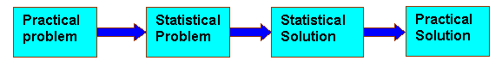
Six-Sigma has following methodologies:
1. DMAIC: Define, Measure, Analyze, Improve and Control
2. DMADV: Define, Measure, Analyze, Design and Verify
3. DFSS: Design for six sigma by IDOV- Identify, design, optimize and validate
4. BPMS: Business process management systems, nine-step process
1. DMAIC: Define, Measure, Analyze, Improve and Control:
In this method Six sigma projects go through four phases:
The number of 'x' s go on getting eliminated using various statistical and other tools. This is as if the variation is getting reduced as it passes through a funnel of the six-sigma methodology. This is sometimes called the breakthrough strategy.
Figure 4.5: cause and effects relationship between the KPOVs ('y's) and KPIVs ('x's) gets clearer as shown below
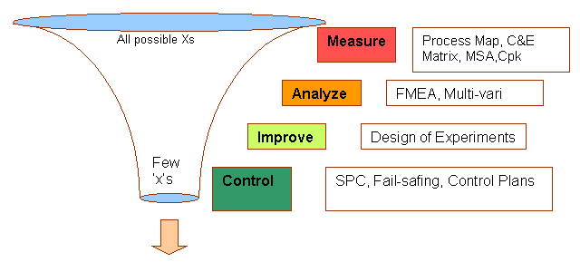

The cause and effects relationship between the KPOVs ('y's) and KPIVs ('x's) gets clearer as the project goes through the four phases. Control plans are documented before the closure of the project so that gains are sustained. The project leaders must demonstrate that the key deliverables of the project are achieved and demonstrated.
D | Define the goals of the improvement activity. At the top level the goals will be the strategic objectives of the organization, such as a higher ROI or market share. At the operations level, a goal might be to increase the throughput of a production department. At the project level goals might be to reduce the defect level and increase throughput. Apply data mining methods to identify potential improvement opportunities.
M | Measure the existing system. Establish valid and reliable metrics to help monitor progress towards the goal(s) defined at the previous step. Begin by determining the current baseline. Use exploratory and descriptive data analysis to help you understand the data.
A | Analyze the system to identify ways to eliminate the gap between the current performance of the system or process and the desired goal. Apply statistical tools to guide the analysis.
I | Improve the system. Be creative in finding new ways to do things better, cheaper, or faster. Use project management and other planning and management tools to implement the new approach. Use statistical methods to validate the improvement.
C | Control the new system. Institutionalize the improved system by modifying compensation and incentive systems, policies, and procedures, MRP, budgets, operating instructions and other management systems. You may wish to utilize systems such as ISO 9000 to assure that documentation is correct.
An important consideration throughout all the Six Sigma steps is to distinguish which process sub steps significantly contribute to the end result. The defect rate of the process, service or final product is likely more sensitive to some factors than others. The analysis phase of Six Sigma can help identify the extent of improvement needed in each sub step in order to achieve the target in the final product. It is important to remain mindful that six-sigma performance (in terms of the ppm metric) is not required for every aspect of every process, product and service. It is the goal only where it quantitatively drives (i.e., is a significant "control knob" for) the end result of customer satisfaction and profitability.
2. DFSS (Design Foe Six Sigma) by Identify Design Optimize and Validate (DOV):
Design for Six Sigma (DFSS) is a systematic integration of tools, methods, and processes for new product and service development. New product / service development is a business process focused on improving profitability. Properly applied, DFSS is a powerful management technique that generates the right product at the right time at the right cost.

Importance of DFSS:
Innovation is the lifeblood of most organizations. For the majority of organizations, long-term success is tied directly to the new product development process. Tomorrow’s revenue and growth are tightly bound to how successful you are at launching new products and services. And yet, the development effort faces many challenges in practice.
By providing tools and teamwork to get the job done in an efficient and effective manner, DFSS can serve as a mechanism to revolutionize the way you develop new products. Through rigorous application of the DFSS process and tools, you can achieve high product quality, market acceptance, and competitive advantage through innovation
Element of training in DFSS:
In three days of comprehensive training. The focus will be on driving innovation in your organization using DFSS methodology and understanding how to overcome challenges to successful implementation.
Objectives:
- Introduce the DFSS methodology and explore the secrets of success of some of the world’s most innovative companies.
- Introduce effective team design methods.
- Introduce portfolio management concepts and tools.
- Provide product development process audit tools.
- Examine approaches for successful implementation of DFSS
Participant Benefits:
- A customer and competitor-oriented perspective of innovation.
- An enhanced ability to recognize barriers to new product success early and adjust quickly.
- A working knowledge of all phases of the new product development cycle, integrating both business and technical elements.
- An appreciation of how to design and lead cross-functional DFSS project teams.
- An understanding of how and when to use structured tools and methodologies for new product / service development (e.g., design analysis, voice of the customer, quality function deployment, Pugh analysis, failure and error mode effects analysis).
3. Business Process Management system (BPMS):
Business process management System (BPMS) is the process to have end-to-end visibility and control over all parts of a long-lived, multi-step information request or transaction that spans multiple applications and people in one or more companies. Business process management means harnessing and enhancing the value of business processes however large or small, wherever they reside within the extended enterprise, and whomever they involve.
Naturally, companies have always created some type of process management system to varying degrees. These earlier solutions might have been custom-built combinations of workflow, document management, or systems automation with large amounts of custom coding needed to round out the capabilities. Typically, no one tool has been capable of providing a satisfactory solution and has left enterprises with large functional gaps and added complexity. With the technology available today, however, new software solutions are available that make strong foundations for business process management a reality.
A BPM solution is for modeling, integrating, monitoring, and optimizing process flows of all sizes, crossing any application, company boundary, or human interaction. To understand the uses of BPM, we must begin with the building blocks of processes. These are the assets that fulfill a process. These assets are employees, customers, partners, applications and database all working toward a specific business goal. Each of these assets has an intrinsic value and part to play in the unifying process. Employees add their intellectual capital to make decisions. Customers drive demand and requests for products and information. Partners share information that impacts design, delivery, and support of products. Applications provide functionality to calculate, store, and retrieve data. Databases hold the history of a company, its products, and customer information. Each asset in a business process adds a piece of value. BPM entails integrating each asset to expose its functionality or value and coordinate the efforts of all assets to achieve a specific goal in a given sequence within a set amount of time.
4. DMADV (Define Measure Analyze Design and Verify):
It is a method similar to that of DMAIC. These can be explained as follows:
DMAIC and DMADV are both:
- Six Sigma methodologies used to drive defects to less than 3.4 per million opportunities.
- Data intensive solution approaches. Intuition has no place in Six Sigma -- only cold, hard facts.
- Implemented by Green Belts, Black Belts and Master Black Belts.
- Ways to help meet the business/financial bottom-line numbers.
- Implemented with the support of a champion and process owner.
DMADV | Define  Measure  Analyze  Design  Verify | - Define the project goals and customer (internal and external) deliverables  - Measure and determine customer needs and specifications  - Analyze the process options to meet the customer needs  - Design (detailed) the process to meet the customer needs  - Verify the design performance and ability to meet customer needs
The difference between DMAAIC and DMADV:
Though both these methods of six sigma have certain similarities, there are a few differences that are to be considered. Theses are as follows:
Usage: The DMADV methodology, instead of the DMAIC methodology, should be used when:
- A product or process is not in existence at your company and one needs to be developed.
- The existing product or process exists and has been optimized (using either DMAIC or not) and still doesn't meet the level of customer specification or six sigma level.

5. THE LEVELS OF SIX SIGMA
Master Black Belt / Champion:
This is the highest level of technical and organizational proficiency. Master Black Belts provide technical leadership of the Six Sigma program. Thus, they must know everything the Black Belts know, as well as understand the mathematical theory on which the statistical methods are based. Master Black Belts must be able to assist Black Belts in applying the methods correctly in unusual situations. Whenever possible, only Master Black Belts should conduct statistical training. Otherwise the familiar “propagation of error” phenomenon will occur, i.e., Black Belts pass on errors to green belts, who pass on greater errors to team members. If it becomes necessary for Black Belts and Green Belts to provide training, they should do only so under the guidance of Master Black Belts. For example, Black Belts may be asked to provide assistance to the Master during class discussions and exercises. Because of the nature of the Master’s duties, communications and teaching skills are as important as technical competence.
Black Belt:
Candidates for Black Belt status are technically oriented individuals held in high regard by their peers. They should be actively involved in the process of organizational change and development. Candidates may come from a wide range of disciplines and need not be formally trained statisticians or engineers. However, because they are expected to master a wide variety of technical tools in a relatively short period of time, Black Belt candidates will probably possess a background in college-level mathematics, the basic tool of quantitative analysis. Coursework in statistical methods should be considered a strong plus or even a prerequisite. As part of their training, Black Belts receive 160 hours of classroom instruction, plus one-on-one project coaching from Master Black Belts or consultants.
Successful candidates will be comfortable with computers. At a minimum, they should understand one or more operating systems, spreadsheets, database managers, presentation programs, and word processors. As part of their training they will be required to become proficient in the use of one or more advanced statistical analysis software packages. Six Sigma Black Belts work to extract actionable knowledge from an organization’s information warehouse. To assure access to the needed information, Six Sigma activities should be closely integrated with the information systems (IS) of the organization. Obviously, the skills and training of Six Sigma Black Belts must be enabled by an investment in software and hardware. It makes no sense to hamstring these experts by saving a few dollars on computers or software.
Green Belt:
Green Belts are Six Sigma project leaders capable of forming and facilitating Six Sigma teams and managing Six Sigma projects from concept to completion. Green Belt training consists of five days of classroom training and is conducted in conjunction with Six Sigma projects. Training covers project management, quality management tools, quality control tools, problem solving, and descriptive data analysis. Six Sigma champions should attend Green Belt training. Usually, Six Sigma Black Belts help Green Belts define their projects prior to the training, attend training with their Green Belts, and assist them with their projects after the training.
6. STRATEGIES FOR SIX SIGMA INTRODUCTION
There are three different strategies adopted by different organizations:
1. The six-sigma organization:
In this strategy, the whole organization is trained on six sigma philosophy and methods. The training is of varying depth for various levels. Six sigma serves as motivational device and also as a metric. Goals are defined in terms of sigma. While the organization can have a common language of six sigma, large resources are required for training. All improvement ideas are likely to be credited to six sigma regardless of the approach actually used.
2. The Six Sigma Engineering Organization:
Here, the attempt is to develop skills in the Engineering functions. The project objectives are usually based on new products, product changes or problem solving. One of the advantages is the relatively higher level of educational and technical background of the individuals that enables them to learn at a faster pace. On the other hand, individuals from other functions do not appreciate the efforts in absence of the awareness of the techniques.
3. Strategic selection of six sigma projects:
The senior management sometimes feels that the current quality processes are generally working well to achieve the overall strategic plan. Hence six sigma tools and concepts are used to enhance the existing quality processes and supplement the skills of the key people thereby making breakthrough improvements. Six sigma projects are identified considering the:
- Strategic direction of the company
- Impact on the bottom-line
- Impact on customer satisfaction

II) GLOBAL PERSPECTIVE OF WHAT MAKES SIX SIGMA WORK
Six Sigma only appears to be a little different than TQM in terms of Quality tools, techniques, and principles, but from a global perspective it's a whole new animal for the following reasons (in order of importance):

A New Type of Top Level Support:
Universal cost oriented metrics and the new level of competition that Six Sigma provides easily acquires top-level support. Even CEOs are seriously supporting large improvement projects run by highly trained business super stars.
- Problem Solving and Team Leading Super Stars:
Executive Champion, Deployment Champions, Project Champions, Master Black Belts, Black Belts, and Green Belts.
- Training Like Never Before:
Much more training for all involved. The training is heavily statistical, project management, and problem solving oriented. Black Belt is well justified by the savings per project.
- New Metrics: Use of metrics unlike anything ever used before. These metrics not only tie in customer Critical to Quality needs with what is measured by the company, but they also allow processes within the company to be compared with each other using a single scale called DPMO (Defects Per Million Opportunities).
- Much Better Use of Teams:
Very efficient use of highly trained, cross-functional, and empowered teams to locate and make improvements. Black Belts are also trained team efficiency experts.
6. A New Level of Process Comparison:
The use of opportunity divisible defect metrics (DPMO) allows comparisons from division to division, department to department, process-to-process, etc. within the company.
7. A New Corporate Attitude / Culture:
Implementation of Six Sigma creates a new environment that naturally promotes the creation of continuous improvement efforts.

III) WHY SIX SIGMA WORKS?
A Six Sigma program integrates the elements of management culture and quality techniques that are critical to driving performance improvement and business excellence.
Six Sigma projects are results-oriented.
- Their leaders are held accountable for return on investment
- Projects are selected and driven by data
- Senior managers sponsor improvement projects
- A critical mass of people is trained in quality improvement techniques
- Achievement is recognized
- Success is celebrated to create momentum and encourage a chain reaction through the organization
- Revealing Those Hidden Costs.
WHY SIX SIGMA WORKS IN AS ORGANISATION?
Turning around an organization requires a clear understanding of roles and responsibilities, as well as the proper tools and techniques to accomplish it. Six Sigma is a proven way to examine, refine, improve processes and eliminate defects. They are committed to teaching and utilizing it to make your products and service the standard by which the rest of the industry is measured.
Some tips that show Why Six Sigma Works in as Organization:
- To produce higher quality goods and services
- To work smarter, not harder
- To exceed customer expectations
- To earn your competitive edge
- To enhance your growth
- To promote job security
- To map all of your processes and to make them defect free
- To learn the language of CHANGE and STATISTICS.

IV) BENEFITS OF SIX SIGMA
The Cost of Quality
Table 4.6: This table demonstrates that as the quality capability of the organization improves, the overall cost of quality reduces offering a major competitive advantage to higher rating organizations.
SIGMA LEVEL | DEFECTS PER MILLION OPPORTUNITIES | COST OF QUALITY
2 | 308,537 (non competitive companies) | Not applicable
3 | 66,807 | 25-40% of sales
4 | 6,210 (industry average) | 15-25% of sales
5 | 233 | 5-15% of sales
6 | 3.4 (world class) | < 1% of sales

Each sigma shift provides a 10% net income improvement.
Financial Benefits of Six Sigma Projects:
Creates additional/new revenue.
Creates cost savings through tax avoidance.
Enables cost avoidance.
Faster return on investments.
Increases cash flow.
Increases profitability of existing products/services.
Increases revenue of existing sources.
Increases stock price/shareholder value.
Lowers cost of production.
Lowers cost of servicing.
Organizational Benefits of Six Sigma Projects
Builds company reputation.
Creates new customer opportunities.
Fosters company vision and mission.
Improves market position relative to competitors.
Improves the ability to serve customers.
Increases competitiveness and ability to charge a premium.

Operational Benefits of Six Sigma Projects
Decreases employee work loads for undesirable work.
Eliminates non-value added activities.
Improves employee morale / team spirit.
Improves internal communication between departments and groups.
Improves use of workspace.
Increases employee and process productivity.
Reduces cycle time.
Reduces cycle time of production/process.
Reduces external inputs to processes.
Reduces person-hours.
Reduces process steps.
Simplifies processes and workflow steps.
Information Technology Benefits of Six Sigma Projects
Decreases maintenance/support costs.
Enables service level agreement (SLA) obligations.
Improves application/system performance.
Improves application/system utilization rate.
Increases efficiency of support activities.
Increases productivity through automation.
Maintains intellectual property investment.
Preserves value of technology.
Reduces application/system variation (increases reliability).
Strengthens application/system security.
Listing out all these benefits clearly shows the potential impact that the six sigma process can have on any organization. The question is that how does one achieve six sigma. I will throw some light on that part of it in the application section of this project from my understanding on how to achieve six sigma. Just to conclude on why I chose this topic for my project on quality control I would like to say that six sigma can achieve in the following success factors:
- Cost reduction
- Productivity improvement
- Market share growth
- Customer retention
- Cycle time retention
- Defect reduction
- Culture change
- Product/service development
- Generates sustained success
- Sets a performance goal for everyone
- Enhances value to customers
- Accelerates the rate of improvement
- Promotes learning and “cross-pollination”
- Executes strategic change

IV. LIMITATIONS /BOTTLENECKS OF SIX SIGMA
- Delays in project execution: There are often significant delays in Six Sigma projects and intermediate deliveries. One of the most frequent reasons is decision-making errors that lead to rework and time-consuming data collection activities. Other reasons are listed below in relation to Six Sigma project phases.
- Faults in Project Phases
a) Define/Identify Phases
  - Poor project selection and/or problem formulation.
  - Non-exhaustive list of potential directions for change and/or for innovation.
  - Underestimated secondary problems which may arise during and/or as a result of primary problem solving.
  - Poor definition of alternative causes and effects and screening of significant inputs.
  - Failures caused by narrowing the scope of the projects in the wrong direction.
b) Measure Phase
- Time-consuming data-collection and measurements.
- Lack and/or high variability of measurement systems.
- Failure in finding root cause.
c) Improve/Design Phase
- Lack of really productive and/or innovative ideas for improvements (upgrade to 4 sigma level and higher) or lack of competitive design or redesign.
- Time and labor consuming DOE.
d) Verify/Control Phases
- Non-systematic and non-exhaustive failure prediction
- These reasons lead not only to delays, but also increase the Cost of Poor Quality (COPQ) due to rework. Repeated idea collection, endless meetings and discussions, screening the alternatives, measurements and analysis also significantly deteriorate overall acceptance and support of further deployments.
- The need for additional efficient analytical techniques and tools, which not only accelerate the above decision-making activities but also make decision-making and problem-solving activities error-prone, increase their productivity and reduce cycle time, and increase Roll Throughput Yield of innovative and competitive solutions through the whole Six Sigma process, is apparent and urgent.
e) Small and medium size companies or business units, who actively enter the Six Sigma community, have additional limitations when deploying Six Sigma methodology:
  - Personnel are limited and often working overtime.
  - It is often difficult (if not impossible) to find suitable candidates for Black and Green Belt positions to lead Six Sigma projects on either a full-time or part-time basis.
  - Resources, both financial and human, for Six Sigma projects are extremely limited. Black and/or Green Belts are often left to conduct their projects on an overtime basis.
- Innovative products and services are critical to business survival and should be introduced or updated as quickly as possible.
- Big capital investments are often avoided or postponed, even when their return on investment is very high and financial justification convincing.

V) SIX SIGMA V/S TQM
Six Sigma is not just a new term for Total Quality Management (TQM). They have many similarities and are compatible in many business environments. TQM has brought great improvements and value to many companies. Six Sigma can do more.
TQM is the development, deployment, and maintenance of systems related to quality-producing business processes. TQM is a strategic approach that focuses on encouraging a continuous flow of incremental quality improvements. It encourages the establishing of a culture of collaboration among different departments within organization. TQM is mainly a cultural initiative and a style of management toward increased quality.
Six Sigma is not just another quality initiative or process improvement program. It is more than that because it is a robust continuous improvement strategy and process that includes cultural methodologies such as the various TQM approaches. Six Sigma is complementary to TQM initiatives such as ISO 9000 registration, which is mainly procedural; Total Quality Management (TQM), which is mainly cultural, and Statistical Process Control (SPC), which is primarily statistical process control monitoring. All of these initiatives and attempts to improve quality levels but typically reach a plateau. The
Six Sigma approach goes to the next level.
Six Sigma is not about quality in the strict traditional sense. Quality, defined traditionally as conformance to internal requirements, is not the focus of Six Sigma. True, Six Sigma focuses on improving quality by helping organizations produce products and services better, faster and cheaper. However, it accomplishes that by reducing waste. In traditional terms, Six Sigma focuses on defect prevention, cycle time reduction, and cost savings. Six Sigma is about helping the organization make more money. Unlike cost-cutting programs that reduce value and quality, Six Sigma identifies and eliminates costs that provide no value to customers: the costs incurred due to waste.
The focus of TQM initiatives differs from the focus of Six Sigma programs. One, TQM programs focus on improvement in individual operations with unrelated processes. Six Sigma focuses on making improvements in all operations within a process. Two, Six Sigma involves dedicated, full-time resources the "black belts" versus TQM, which is usually a part-time activity of non-dedicated managers.
The breadth and depth and the precision of Six Sigma and TQM also differ. Six Sigma has a well-defined project charter that outlines the scope of a project, financial targets, anticipated benefits, milestones, etc. It's based on hard financial data and savings. In TQM, organizations go into a project without fully knowing what the financial gains might be. Six Sigma has a solid control phase (DMAIC – Define-Measure-Analyze-Improve-Control) that makes specific measurements, identifies specific problems, and provides specific solutions that can be measured.

a) How else is Six Sigma different?
Six Sigma is:
- Fact based and data driven.
- Results-oriented, providing quantifiable and measurable bottom-line results
- A leader-sponsored top-down approach
- Linked to strategy
- Thinking about customer requirements
- Applicable to all business processes - administrative, sales, marketing, R&D, etc.
Six Sigma is a robust continuous improvement strategy and process that includes cultural methodologies such as Total Quality Management (TQM), process control strategies such as Statistical Process Control (SPC) and other important statistical tools. Six Sigma tools and techniques all are found in total quality management. Six
Sigma is the application of the tools on selected important projects at the appropriate time. Six Sigma tools and techniques all are found in TQM. When done correctly, Six Sigma becomes a way toward organization and cultural development. Yet, it is more than a set of tools!

VI. Is This a Six Sigma, Lean, or Kaizen Project?
This is a familiar question that is often addressed by organizations. In fact, it's the wrong question. These concepts are nothing more than tools in your management toolbox. You don't fix a watch with a hammer, and you get the same results when you deploy Six Sigma, Lean, and Kaizen incorrectly. The fact is, a business problem is a business problem, and it needs to be fixed. Understanding the application of these tools to various improvement opportunities is the key to success.

Figure below provides a perspective on how to integrate Six Sigma, Lean, and Kaizen into a total business improvement strategy.
Figure 4.7 : Integrate Six Sigma, Lean and Kaizen
Leadership, Creativity, Innovation
Kaizen
Lean
Six Sigma
- DNAIC Process
- Statscal Tools
- Value Steam Mapping
- PFMA
- Cp & Cpk
- Gage R&R
- ANOVA Hypethesis
- Tests, DOE, Otimization

- One Piece Flow
- Cells
- Visual Controls
- Pull Systems
- Kanban
- Setup Production
- TPM

- Quick Strike
- 1-6 Days
- Process Mapping
- Caves& Effect
- 0 as is “0 locking &Tracking “Tool
Knowledge
Of Tools

Closed Loop
Performance
- Waste,Non-Value Added
- Speed, Cycle Time
- Standarization
- Inventory Performance
- Logistic Cost Reduction
- Variance Reduction

- Complex Problems
- Variation Reduction
- Process Capability
- Defactive Prevention
- Stability , Predictiablity
- Design Excellence

- Simple Tactical Focus
- Obvious Quick Tools
- Confamation
- Plug hold in Dilus

Focus On
Improvement

Teaming and Employee Involvement

People spend months drilling the Six Sigma process and statistical tools into their heads until they look at every situation as a Six Sigma problem. Why not? It was a very successful and rewarding experience for these individuals. But it's also easy to make mountains out of molehills. You don't want the organization running around performing DOEs on the internal mail system or the quality of cafeteria food. On the other extreme, some high anxiety managers tend to look at very complex process variation or larger scale strategic problems as a Kaizen Blitz that can be fixed by tomorrow. They're looking for instantaneous improvements in more complex areas such as variance reduction, customer returns, or forecast accuracy. For these situations, one question to reflect upon is "How long did it take us to get into this situation?"
The most important driver of breakthrough improvement is leadership, creativity, and innovation. Executives must lead and mentor their people in the right directions and assure that their actions are linked to strategic performance. They need to deploy limited resources to the highest impact areas and not try to solve every problem in the company.
To accomplish this, they need to understand Six Sigma, Lean, Kaizen, and other improvement methodologies, and how to integrate these tools into an overall business improvement strategy.
Refer to the framework in Figure 1: "Integration of Six Sigma, Lean and Kaizen." Every strategic improvement initiative requires the following infrastructure shell:
Leadership, Creativity, and Innovation:
This element aligns strategy and deployment, mentors the organization through the right execution path, and drives cultural change. When the leadership team understands Six Sigma, Lean, and Kaizen they can provide clearer focus on what needs to be done to improve profitability and competitiveness.
Teaming and Employee Involvement:
This element provides the connection between concept and reality. People understand the need to change, they are equipped with the right tools, and they are empowered to take action.
Closed-Loop Performance:
This element pegs accountability and process ownership. Real time performance measurement also allows people to better understand the cause-and-effect relationship between their actions and the improvement goals.
Some improvement opportunities are fruit on the ground or low hanging fruit, and can be harvested through several quick-strike Kaizen Blitz efforts. These are the obvious localized no-brainers that we trip over everyday. The solution is not rocket science. It is simplicity, action, and common sense.
As you move from left to right in Figure 1, the scope and complexity of the improvement opportunity increases, but so do the potential benefits. Lean Manufacturing typically focuses on speed, elimination of waste, standardization, and flexibility/ responsiveness. Most Lean efforts begin on the production floor, however, the philosophy and tools are equally applicable in "soft process" areas such as new product development, distribution/ logistics, supply chain management, accounting/ finance, and customer service.
On the right side of Figure 1 is Six Sigma. These are the highest impact opportunities because we are deep core drilling into the hidden Cost Of Poor Quality (COPQ). Making a dent in these areas often results in cost reductions of 2%-7% of annual revenues for successful organizations. Six Sigma is a data-driven methodology that strives for perfection in the organization's entire value chain. Six Sigma examines variation and root causes of current performance, with a focus not only on the production floor, but on all key business processes. With Six Sigma, the entire organization is placed under the microscope. The methodology and statistical tools provide structure, discipline, and a logical progression for achieving breakthrough improvements. Executives continue to send their employees off to Six Sigma, Lean, or Kaizen boot camps to learn the tools, but they are often disappointed with the lack of results. Executives who develop a working knowledge of Six Sigma, Lean, and Kaizen are much better prepared to build the right infrastructure and lead their organizations to both financial and human success.

I) RESEARCH METHODOLOGY
Research methodology makes the most important contribution towards the enrichment of study. In a research there are numerous methods and procedure to be applied but it is the nature of the problem under investigation that determines the adoption of a particular method for all studies. Methods selected should always be appropriate to the problem under investigation.
Data or information lies at the basis of any research. The data for my research has been conducted through both primary as well as secondary sources. The primary data has been collected mainly from books, journals, magazines & online resources on the Internet. The secondary has been collected by way of observing the quality circle meetings & by conducting informal discussions with the circle members, facilitators, & joint coordinator in the company. Further analyses of the past records & future plans of quality circle activities were done. Data regarding opinion & attitude towards the quality circle system was collected by way of questionnaires designed for the purpose.
For my research, I have made use of questionnaires for ascertaining the attitude of the employees towards the Six Sigma/Quality Circle System at Essar Global Fund Limited.
The main aim of conducting the survey using questionnaires was to determine the:
- Level of improvement in productivity measures,
- To know the technical aspects of the quality circle,
- To determine how successfully the circle is able to solve the problems,
- To determine the effectiveness of the quality circle activities,
- To determine the opinions & attitudes of employees towards the quality circle activities.
HIGHLIGHTS OF THE QUESTIONNAIRE
The main highlights of my questionnaire are as follows:
- The questionnaire is precise & to the point.
- Personal questions have been avoided.
- The language used in the questions is simple & clear.
- There are mostly objective questions (multiple choices).
- Respondents’ feedback has been given due importance. There is provision for their suggestions.
- Confidentiality is guaranteed. The respondent’s have not been asked to disclose their names or identities.
SAMPLE SIZE
100 Employees of Essar Global Fund Limited has been surveyed.

CHAPTER 6

DATA ANALYSIS & INTERPRETATIONS
Table No: 6.1
- Do you think the organization is quality conscious toward employees?
Employees answer | NO. of employees | % of Employees
Yes | 78 | 78%
No | 22 | 22%
Total | 100 | 100%

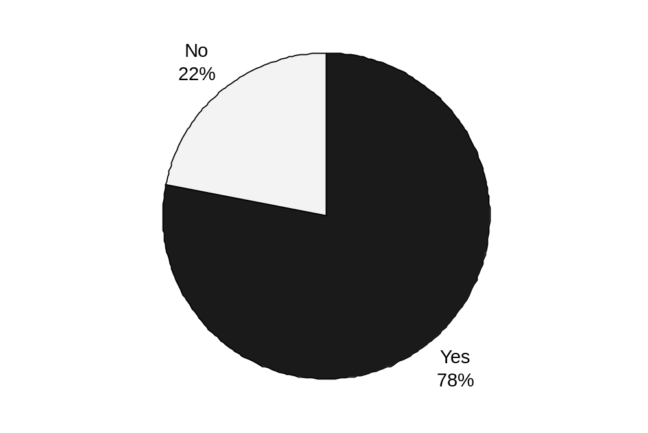

Table No: 6.2
- Does the organization have the certification of ISO 9000?
Employees answer | NO. of employees | % of Employees
Yes | 100 | 100%
No | 0 | 0%
Total | 100 | 100%

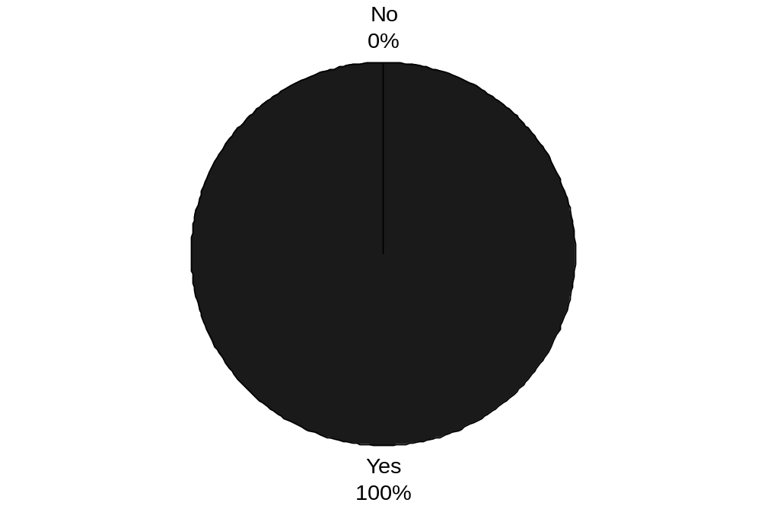

Table No: 6.3
- Is the organization providing quality assurance system & operation?
Employees Answer | NO. of employees | % of Employees
Yes | 100 | 100%
No | 0 | 0%
Total | 100 | 100%

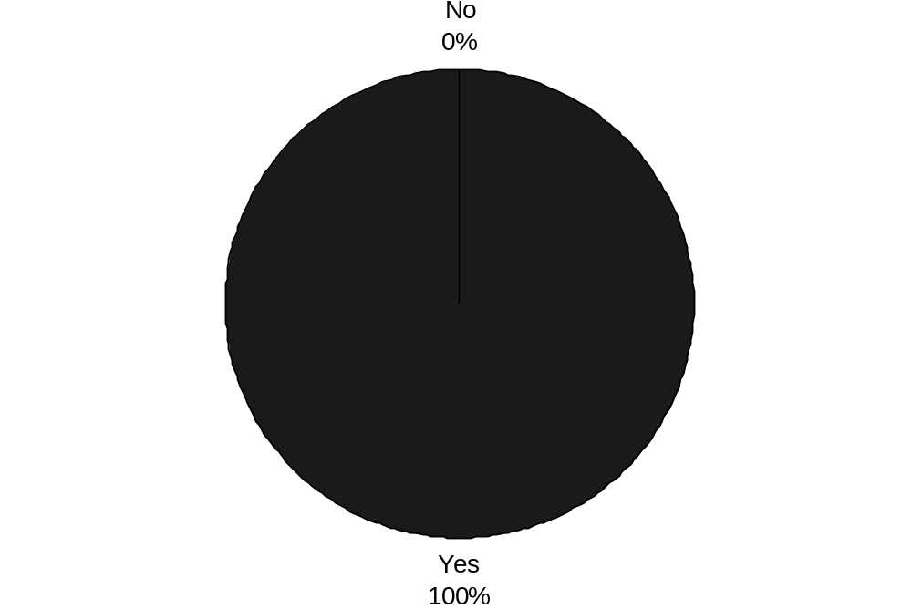

Table No: 6.4
- Does the organization have quality circle?

Employees Answer | NO. of employees | % of Employees
Yes | 100 | 100%
No | 0 | 0%
Total | 100 | 100%

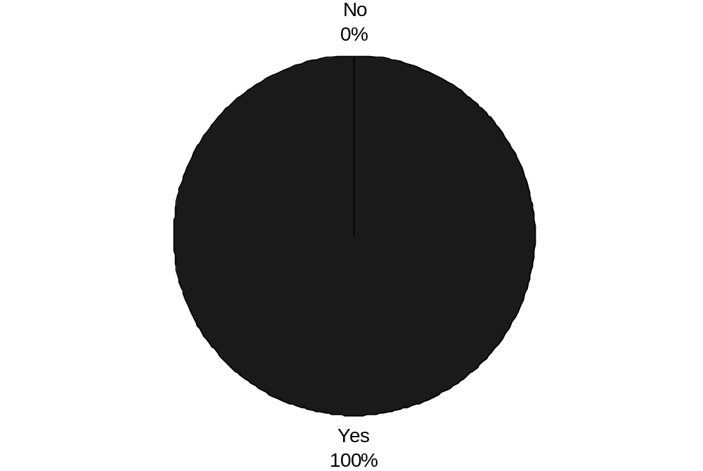
Table No: 6.5
5. How many people are involved in quality circle?
Group of people | Employees Answer | No. of People | % of people
Less than 10 | yes | 70 | 70%
Above 10 | no | 0 | 0%
Above 15 | no | 0 | 0%
 | Can’t say | 30 | 30%
Total |  | 100 | 100%
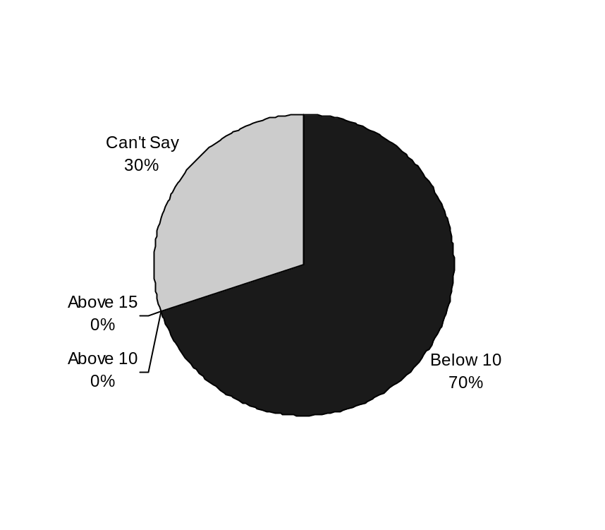

Table No: 6.6
- How frequently the organizations have the meeting of quality circle?
 | NO. of meetings | % Of Meetings
weekly | 100 | 100%
Biweekly | 0 | 0%
Monthly | 0 | 0%
Yearly | 0 | 0%
Total | 100 | 100%
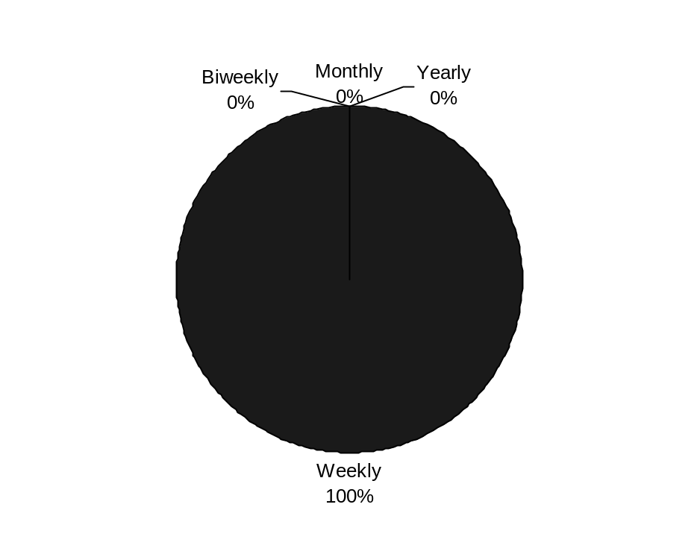
Table No: 6.7
- Do you know about the agenda of information or any other information?
Employees Answer | No. of People | % Of people
Yes | 32 | 32%
No | 68 | 68%
Total | 100 | 100%
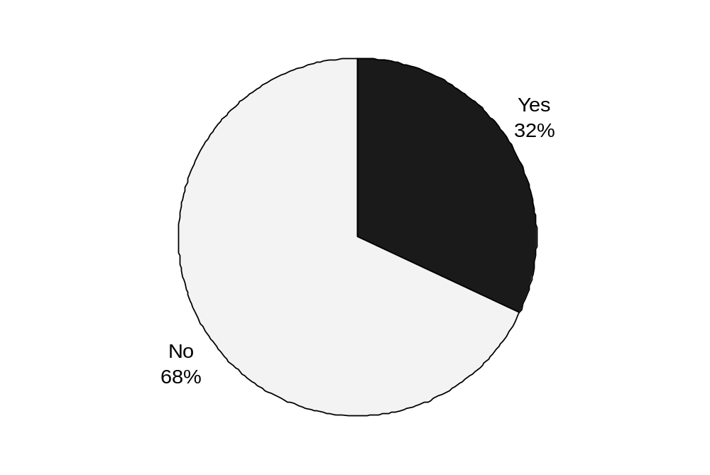
Table No: 6.8
- Does the organization is going for the brain storming session?
Employees Answer | No. Of People | % Of People
Yes | 100 | 100%
No | 0 | 0%
Total | 100 | 100%

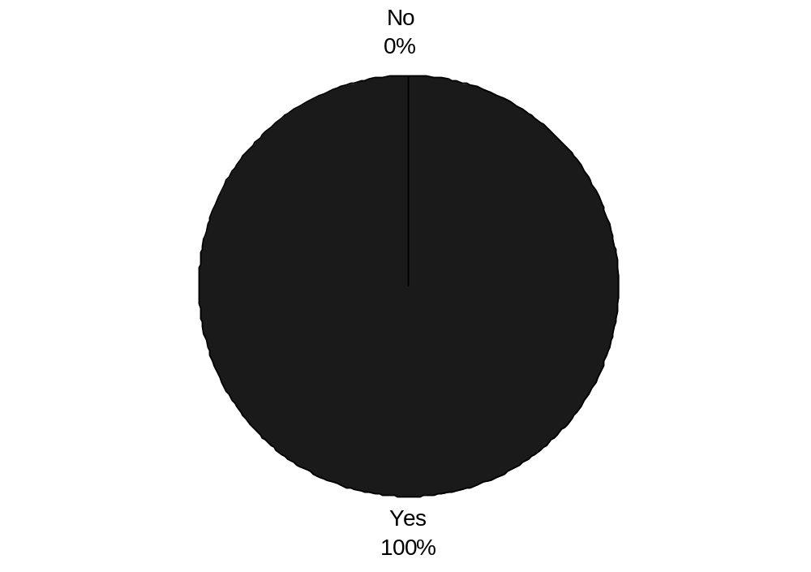
Table No: 6.9
9. Employees are kept updated with changes in job skills & job designs?
Employees Answer | No. Of People | % Of People
Strongly Agree | 12 | 12%
Strongly Disagree | 14 | 14%
Don’t Know | 0 | 0%
Agree | 48 | 48%
Disagree | 26 | 26%
Total | 100 | 100

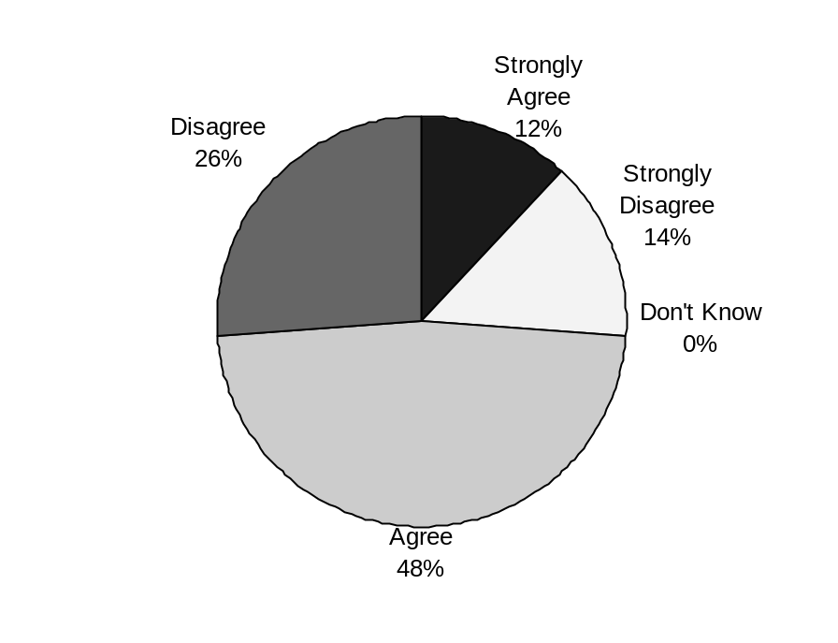
Table No:6.10
10. Formal or informal method is followed for employees feedback and acting on that feedback?
Employees Answer | No. Of People | %Of People
Strongly Agree | 26 | 26%
Strongly Disagree | 32 | 32%
Don’t Know | 0 | 0%
Agree | 36 | 36%
Disagree | 6 | 6%
Total | 100 | 100%
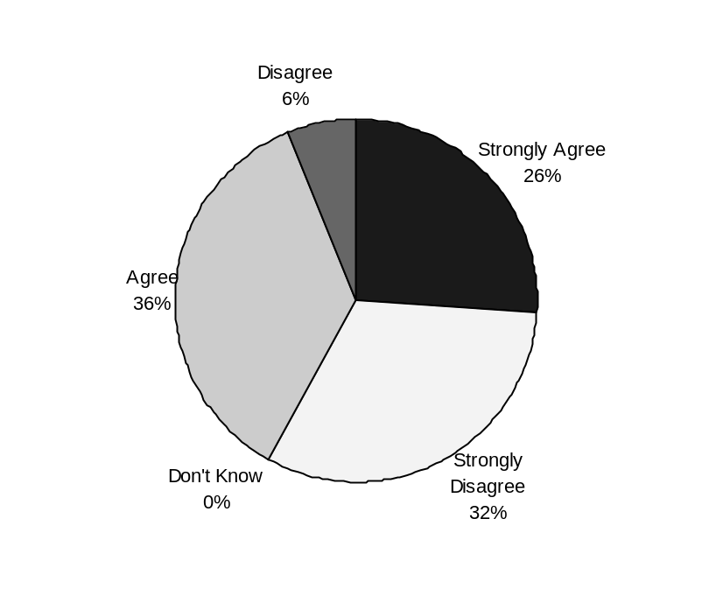
Table No: 6.11
11. Does the organization provide right environment to apply your knowledge from new programs to the job?
Employees Answer | No. Of People | % Of People
Strongly Agree | 20 | 20%
Strongly Disagree | 28 | 28%
Don’t Know | 0 | 0%
Agree | 42 | 42%
Disagree | 10 | 10%
Total | 100 | 100%
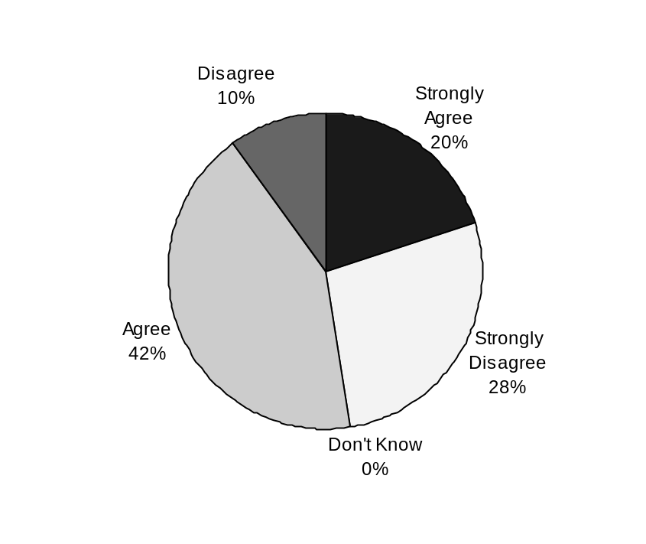
Table No: 6.12
12. Do you feel that the organization is a good place to work?
Employees Answer | No. Of People | % Of People
Yes | 100 | 100%
No | 0 | 0%
Can’t Say | 0 | 0%
Total | 100 | 100%
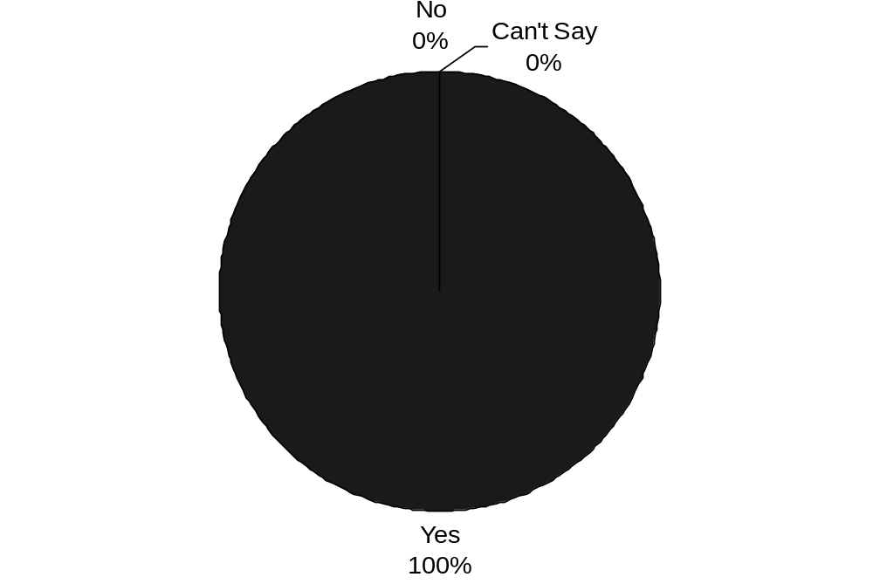
Table No:6.13
13. Do you feel comfortable with rules and policy of the organization?
Employees Answer | Total No. Of People | % of People
Yes | 45 | 45%
No | 55 | 55%
Can’t say | 0 | 0%
Total | 100 | 100%
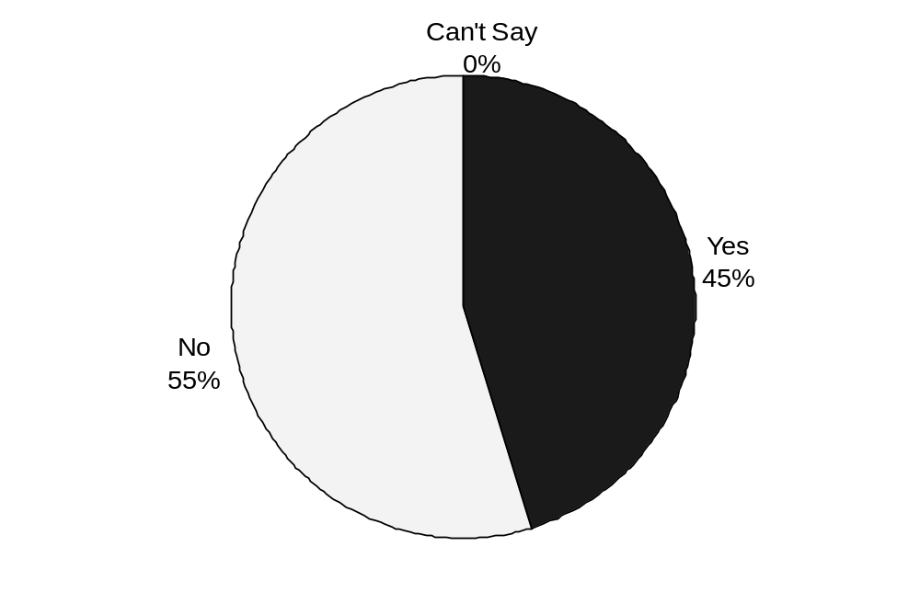

Table No:6.14
14. What types of relations are you having with your superior, peers and subordinates?
If Poor then why it is so?
- They are not cooperating.
Relations | No. Of People | % Of People
Good | 64 | 64%
Average | 34 | 34%
poor | 0 | 0%
Total | 100 | 100%
- Their behavior is not good
- There is no proper communication
- All the above

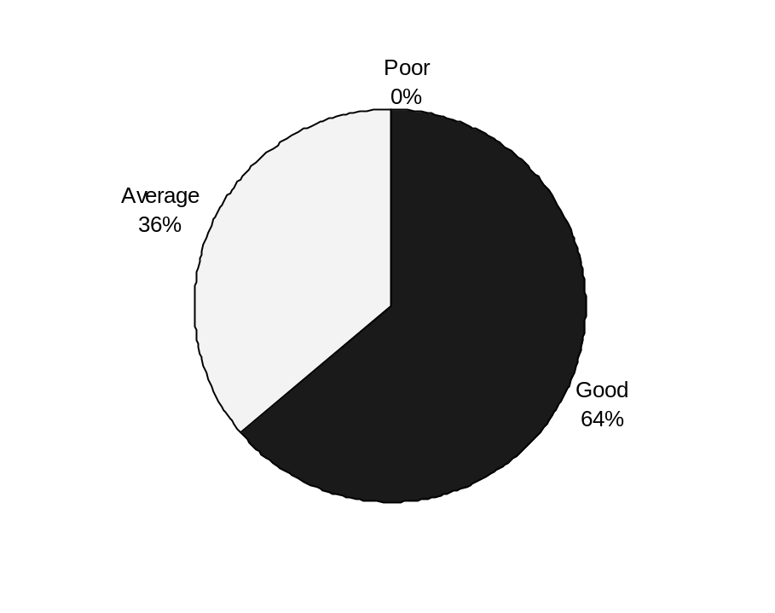

Table No: 6.15
15. Do you feel that you can get ahead in the org. if you make an effort?
Employees Answer | No. of People | % Of People
Yes | 58 | 58%
No | 42 | 42%
Can’t say | 0 | 0%
Total | 100 | 100%

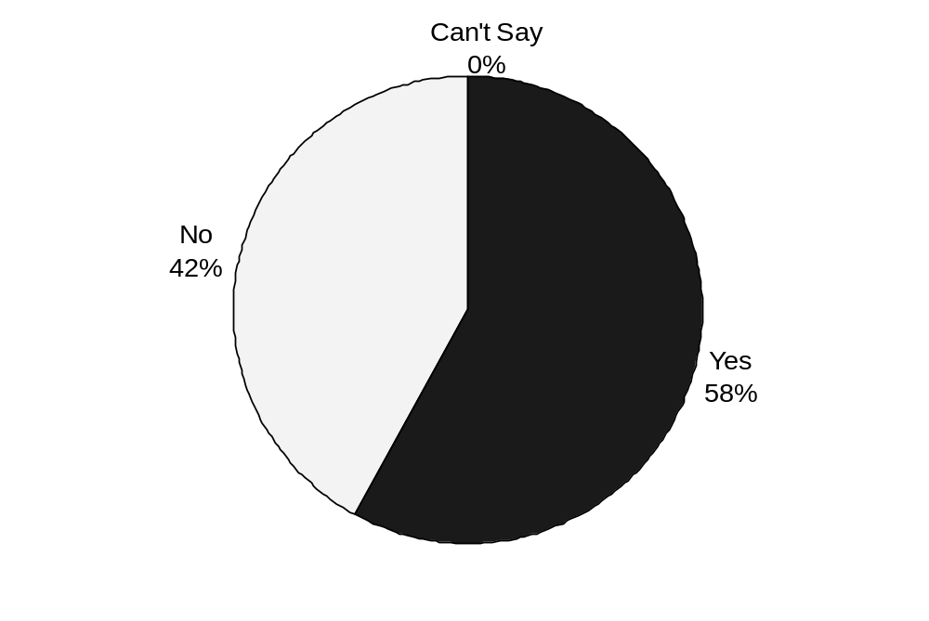

Table No: 6.16
16.Do you get any reward on your good performance?
Employees Answer | NO of people | % of people
YES | 38 | 38%
NO | 62 | 62%
Total | 100 | 100%

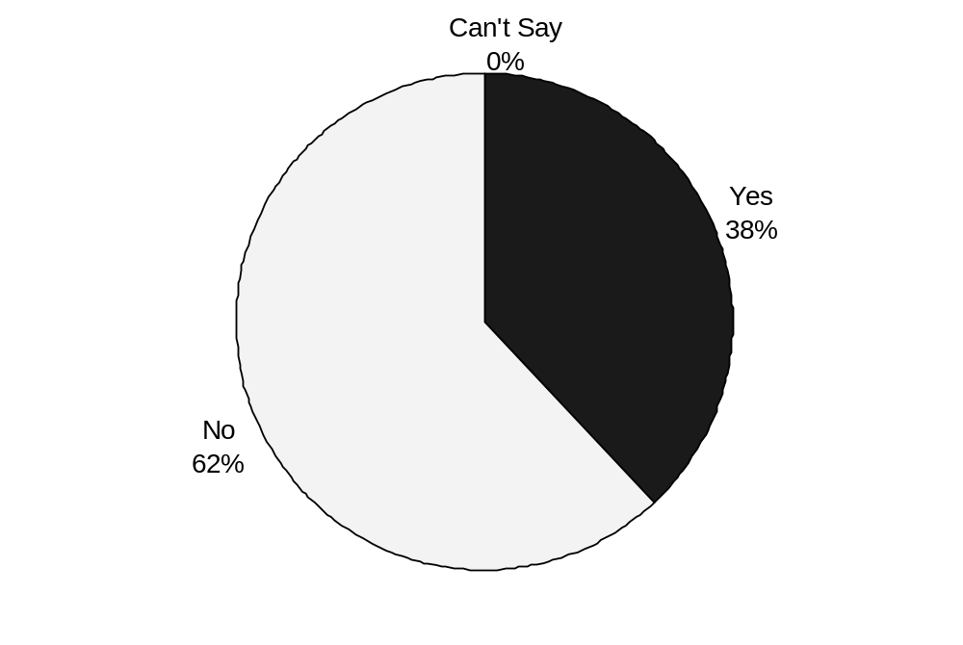

Table No: 6.17
17. Do you find that your performance is properly measured in the organization?
Employees Answer | NO. of people | % of People
Yes | 78 | 78%
No | 22 | 22%
Can’t say | 0 | 0%
Total | 100 | 100%

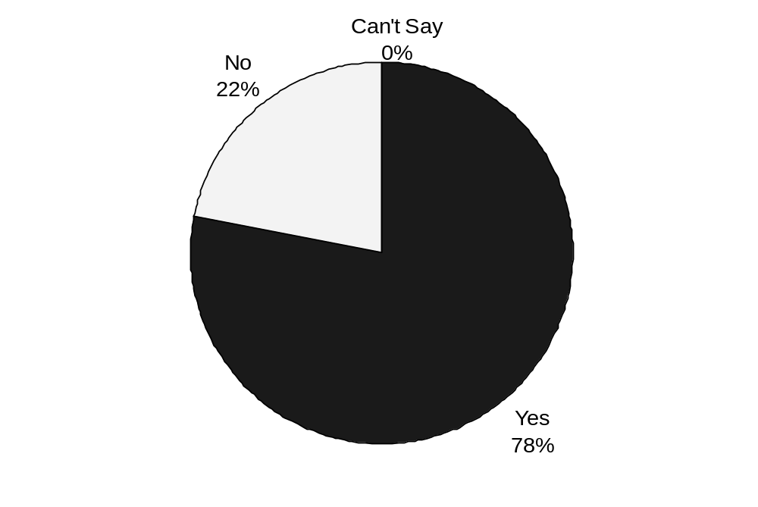

Table No: 6.18
18.Do you find that your job makes the best use of your abilities?
Employees Answer | No of People | % Of People
Yes | 56 | 56%
No | 44 | 44%
Can’t Say | 0 | 0%
Total | 100 | 100%

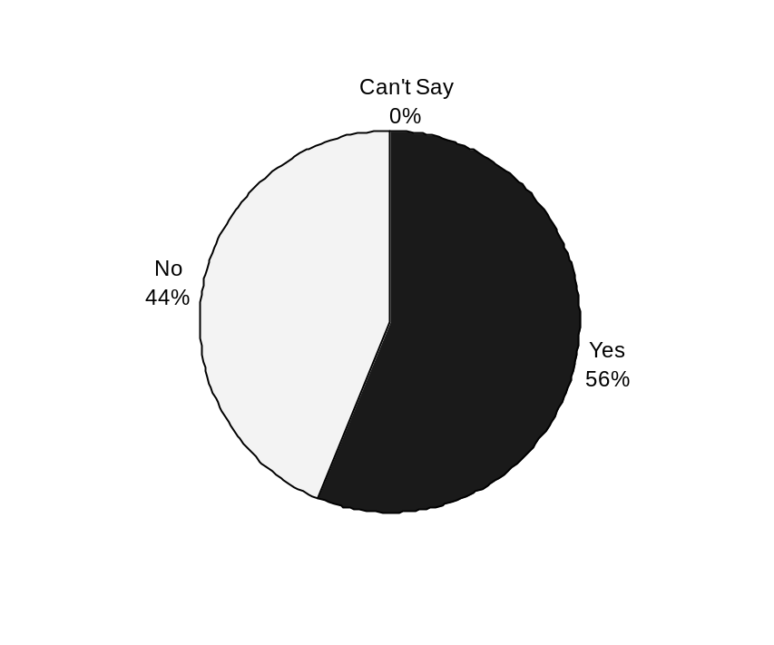

- INTERPRETATIONS
The detailed analyses of the results are explained below:
MOST OF EMPLOYEES FEELS THAT:
- Most of the staff member and worker feel that organization is quality conscious toward the employees. This also increases their commitment toward the work and toward the organization.
- Some of the employee’s feel that they have proper information about the policies, practices followed in the organization. But some of employees feel that there is no proper communication.
- Most of the facts related with the organization are hided by the management from the employees.
- Most of the employees feel that they don’t get rewarded for their good performance.
- Most of the staff members feel that their performance is properly measured in the organization.

CHAPTER 7

RECOMMENDATIONS
- There should be visible support from management
Occasional words of praise & encouragement from all the levels of management go a long way in boosting the morale enthusiasm of the Quality Circles.
In India Chairman & Director of BHEL & HMT personally participate in Quality Circle presentations, which are responsible for the encouraging growth of the Circle concept in their organizations.
- There should not be any delay or non-implementation of Circle recommendations.
Quality Circles do not just identify & analyze problems but they also implement them their own recommendations.
The work related issues of the Quality Circles can be categorized as follows:-
- Those over which circle members have control.
- Those over which circle members have limited control but which require the influence of an outside agency.
- Those over which circle members have neither control nor influence.
- It has been observed that some circles & facilitators think that only those problems should be solved which fall under the category 1. But it should be realized that some of the objectives of the Quality Circles, mainly to make different sections of employees communicate better & to break down the barriers between the workers & other levels of management, this can be achieved if circles are encouraged to tackle every kind of problem, as long as it is related to the work they are doing, irrespective of the fact that it may fall under any of the three category.
- However, quality circles may be guided to give first priority for the problems falling under category 1 & to take up others later.
- Care should be taken to ensure that the suggestions & recommendations given are being considered by the management & other departments.
- Facilitators should become more active in the activities.
Even after training, members need further counseling periodically which facilitators & other executives should not fail to give. It is recommended that changing of facilitators who aren’t interested may have better result is future. Facilitators should be liberal with praise & gesture of recognition to maintain high morale of quality circles.
- Improving communication
There are a number of different ways in which quality circle can improve communication:
- PRESENTATION – The presentation for circles is arranged by the facilitators. The function should be well organized & the top management should attend it.
Invitations should be extended to every body including potential quality circles members from other departments & departmental managers as well as a few representatives from other companies.
- MONTHLY LEADERS MEETING – It is recommended that the leaders of various circles can have monthly meeting of 1 hour in which they could discuss the progress. Through this one group can communicate with each other & give suggestions to each other on how to improve.
- INFORMATION BOARDS – Quality circle information boards are another effective method that can be used. The facilitators can post the accomplishments of circles members, as well as other information material which could create more interest in quality circle programs. The boards should be at a centre point which is easy visible.
- POSTERS – Posters help to communicate effectively many messages about the quality circle programs.
- ANNUAL GATHERINGS AND PICNICS – The Company can organize picnics or gatherings for the members to keep people involved & to create an informal channel.
- There should be regular quality circle activities and meetings. Nothing else demonstrates better to the quality circle members the lack of seriousness on the part of the management than suspending the meeting for 1 month.
Many senior engineers tend to ask the quality circle members to postpone their weekly hour-long meeting on the plea of production pressure. This should be avoided.
There was a case in Essar Global Fund Limited. A senior engineer was reluctant to permit quality circle members to have meetings. But when once he witnessed the case studies given by the quality circle, he became a convert & thereafter, would take the initiative to remind the members of the scheduled meeting.
- Appreciation letters
There is another important function that management should perform, apart from arranging for the presentation & reviewing them, it to present a “thank you” letter to all of the circle members & sent to their home address. This will evoke curiosity about the program & participation proceeds more rapidly.
- Certificates
Once the problem have been solved & given to the management, a certificate showing the completion of the project should be presented to the leader & copies given to the members (see EXHIBIT No. 7). Copies of all the certificates should also be proudly displayed on the notice board to show the circle achievements to the employees of the company.
- Finished problem display
When the problem has been presented to management many details can be displayed in a showcase. This would help to generate more interest & may encourage workers in others areas & in people who are still waiting to join the circles.

- Pictures of circle members
Many companies have used this method to promote circle activities. Group pictures of the circle members at work are taken & displayed in the work area.
- Training
On the basis of the findings it can be concluded that the members are in need of some more training on some behavioral aspects. Like training can be give on:
- Team interaction
- Managerial philosophy,
- Goal setting processes
- And decision making.
- Presentation between circles
According to the findings many circles have a problem that the other circles affect their performance & without realizing this they continue perform in the same manner. Therefore, to solve these circles should have the authority to call any circle in their presentation & present them with the facts, so that they could improve on it. In these it is not necessary that the top management should be present, it is only among the circles to inform each other about their deficiencies.
- Problem of shifts
Shift work presents a problem for circles & the coordinator is also concerned abut how to maintain the regularity of the meetings. To cope with the different times when members are available, two methods have been used successfully for scheduling meetings:
  - Quality circle for each shift can function with a linking pin (one or two people who attend all meetings) being the coordinating mechanism.
  - The second method involves scheduling. For one week, the circle meets one hour before quitting time for the first shift; the next week the circle meets for the first hour of the second shift.
  - There is a third alternative: each shift can form its own circle which is independent of other circles in the unit.
The suggestions I have given for the betterment are explained below:
- It is very important to provide the opportunity to the employees of the organization to express their ideas or whatever they want to express.
- Management should clear their vision mission and goals towards the employees in the organization.
- Management should involve the workers representatives in managerial activities so that the transparency could be maintained and through this they can win the confidence of the employees.
- Management should give due importance to mental relaxation &social cultural development of an employees who strives hard for the company.
- Reward or Praise/appreciation works as magic for an individual and motivates them for work.
- Role clarity of each position should be defined and based on that individuals can plan their work accordingly.
- Self-potential system should be encouraged.
- There are regular review and comparison of current & past performance to detect gradual deterioration in the strategy.
- Proper cooperation should be necessary in the company.

CHAPTER 8

CONCLUSION
One of the more important & significant conclusions which I can draw from my study at Essar Global Fund Limited is that the importance of six sigma was duly recognized by the management. But the enthusiasm by which this chapter was opened at the organization has considerable ebbed especially among the circle members. Two important reasons are responsible.
- Firstly, the enthusiasm by which the six sigma members participate in meetings & strive to come to conclusions about the impending problems with their solutions is not sustained by management. The management according to the findings is not only unable to implement those findings & suggestions but also fail to recognize & appreciate the same. This has severely affected the moral of the members & may of them seem to find quality circle meetings an unnecessary obligation.
- Second, reason is that the duration of training to introduce the employees to quality circles was limited. It would have been better if the training should have been spread over a few days to give better insight to the employees in quality circles.
- The middle management’s efforts have to be appreciated. They have followed an open door policy to help employees & quality circle members to over come their problems. They have showed patience in listening to the suggestions & grievances of quality circle members & have done everything under their control to keep the members going.
Six Sigma has yielded tremendous cost savings while reducing defects, enhancing customer satisfaction, and increasing customer retention at many companies. It has been perceived as a performance improvement strategy available only to the largest companies in the world. However Six Sigma is now providing improved levels of productivity and financial performance to small and medium sized corporations.
There are many benefits of Six Sigma like;
- Six Sigma generates sustained success because it is a way to continue double-digit growth.
- Secondly, it sets a performance goal for everyone in a company no matter the size.
- Thirdly, Six Sigma gets everyone focusing on a common goal. Six Sigma enhances value to customers because the focus on customers is at the heart of Six Sigma.
- Lastly, it accelerates the rate of improvement by borrowing tools and ideas from many disciplines.

ANNEXURE
REFERENCES
BOOKS
B F.W. Breyfogle III, et. al. Managing Six Sigma, John Wiley & Sons, Inc. New York, 1999.
Basu R, ‘Six Sigma to Six Sigma’, HE solution, 2001, vol. 33, No. 7, pp.28-33.
By Rowland Hayler, Michael D. Nichols, Six sigma for financial services: how leading companies are driving results
Connective technologies in the supply chain:Sameer Kumar
Dag Näslund, (2008) "Lean, six sigma and lean sigma: fads or real process improvement methods?", Business Process Management Journal, Vol. 14 Iss: 3, pp.269 – 287.
Dambolena I, and Rao A, ‘What is Six Sigma any way?’, Quality progress, 1994, Vol.33, No.11, pp.10.
Edward D. Arnheiter, John Maleyeff, (2005) "The integration of lean management and Six Sigma", The TQM Magazine, Vol. 17 Iss: 1, pp.5 – 18.
G. Smith, Benchmarking success at Motorola, Copyright Society of Management Accountants of Canada, 1993.
Godfrey, A E, ‘Why Six Sigma?’, Quality progress, Vol.35, No.1, pp. 6-7.
Good Distribution Practices - Health Sciences Authority, Manufacturing & Quality Audit Division, Jan 2008
Man Mohan S. Sodhi, Navdeep S. Sodhi, Six Sigma Pricing: Improving Pricing Operations to Increase Profits.
Monks, G. Joseph (1985), “Operations Management Theory and Problems”, McGraw Hill Book Company, New York.
P. Tadikamala, The confusion over Six Sigma quality, Quality Progress, No. 11 (1994).
Prabhushankar G V, Shalij P R, Thirunavukkarasu V, Devadasan S R, ‘Six Sigma in Indian Industry components sector: A survey’, 2008.
S. Fakin, M. Sokovic, Use of Six Sigma method in the automotive parts production development process, Diploma thesis No. S-556, Faculty of Mechanical Engineering, University of Ljubljana, Slovenia, 2001.

WEBSITES
- http://www.essar.com/
- http://www.moneycontrol.com
- http://www.google.com
- http://www.altavista.com
- https://www.gembaacademy.com
QUESTIONNAIRE
- Do you think the organization is quality conscious toward employees?
Yes 
No 
- Does the organization have the certification of ISO 9000?
Yes 
No 
- Is the organization providing quality assurance system & operation?
Yes 
No 
- Does the organization have quality circle?
Yes 
No 
- How many people are involved in quality circle?
Below 10 
Above 10 
Above 15 
Can’t Say 
- How frequently the organizations have the meeting of quality circle?
Weekly 
Biweekly 
Monthly 
Yearly 
- Do you know about the agenda of information or any other information?
Yes 
No 
- Does the organization is going for the brain storming session?
Yes 
No 
- Employees are kept updated with changes in job skills & job designs?
Strongly Agree 
Strongly Disagree 
Don’t Know 
Agree 
Disagree 
- Formal or informal method is followed for employees feedback and acting on that feedback?
Strongly Agree 
Strongly Disagree 
Don’t Know 
Agree 
Disagree 
- Does the organization provide right environment to apply your knowledge from new programs to the job?
Strongly Agree 
Strongly disagree 
Don’t know 
Agree 
Disagree 
- Do you feel that the organization is a good place to work?
Yes 
No 
Can't Say 
- Do you feel comfortable with rules and policy of the organization?
Yes 
No 
Can't Say 
- What types of relations are you having with your superior, peers and subordinates?
Good 
Average 
Poor 
If Poor then why it is so?
- They are not cooperating. 
- Their behavior is not good 
- There is no proper communication. 
- All above 
- Do you feel that you can get ahead in the org. if you make an effort?
Yes 
No 
Can't Say 
- Do you get any reward on your good performance?
Yes 
No 
Can't Say 
- Do you find that your performance is properly measured in the organization?
Yes 
No 
Can't Say 
- Do you find that your job makes the best use of your abilities?
Yes 
No 
Can't Say 

Thank You

